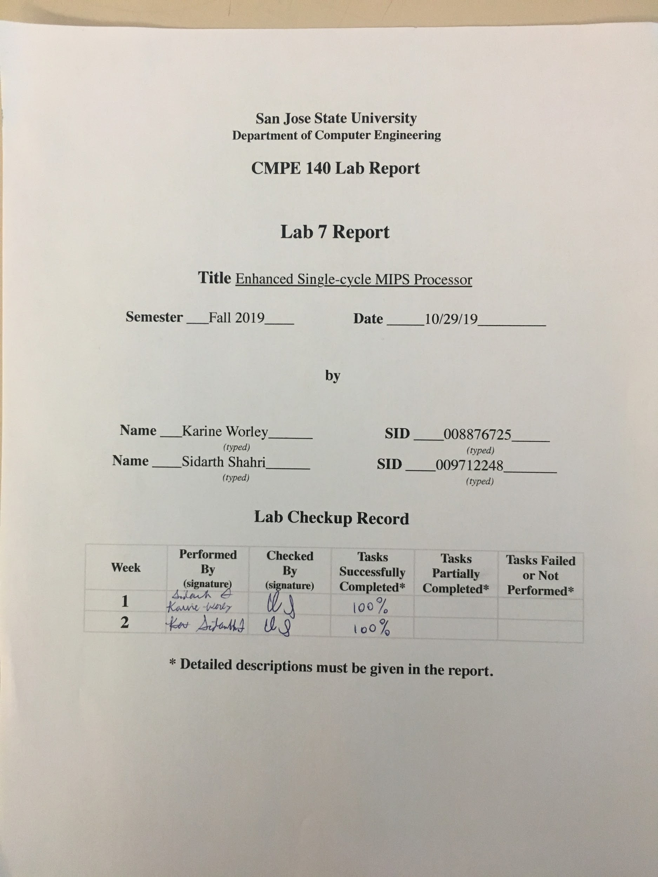

### Purpose

The goal of Assignment 7 was to extend the single-cycle processor design from Assignment 5 and 6 to support the following MIPS instructions: MULTU, MFHI, MFLO, JR, JAL, SLL, and SRL. The assignment was divided into two parts. Previously, we submitted a report detailing the tasks completed in the first part of the assignment. These tasks included designing a first draft of the datapath with microarchitecture supporting these new instructions and creating an updated control unit truth table.

The tasks of Assignment 7 included implementing our drafted design in Verilog, functionally verifying the design with tools in Vivado, and validating the design in hardware on an FPGA device, specifically the Basys3 FPGA board. By completing these tasks, we developed experience with designing a processor and validating the functionality of the design. Since the design of the datapath and its microarchitecture were covered in a previous lab report, it will not be the focus of this report. Instead, this report focuses on the implementation of the design, functional verification, and hardware validation of the design.

### Approach

**MULTU, MFLO, MFLO**

Implementing MULTUrequired creating a new module called “MULT”. The logic for this module was simple: take two 32-bit inputs from register file outputs rd1 and rd2, multiply them together, and output the 64-bit result to a HI and LO register. The HI and LO registers are special d-registers that store an input when the input clock signal is high and an input write enable signal are high. The upper 32 bits of the output of the “MULT” module are stored in HI and the lower 32 bits are stored in LO. Figure 1 shows these modules in the datapath. The implementation in code followed the diagram we designed in Part 1 of this assignment.

The control signals relevant to these modules are “mult_we” and “mult_hilo_sel”. “mult_we” is the write enable signal for the HI and LO registers. “mult_hilo_sel” is the select signal for a mux that controls whether the output of the HI and LO register are forwarded to a register file (via two more muxes explained later). “mult_we” is high when a MULTU instruction is executed to ensure the result is stored. “mult_hilo_sel” is low during a MFHI instruction and high during a MFLO instruction. Another mux controls the output of these instructions and the SLL/SRL instructions controlled by an input “mult_shift_result” control signal. For MULTU, MFHI, and MFLO, this signal is always low.

These control signals are provided by the auxiliary decoder portion of the control unit as these instructions are R-Type instructions. That is, the main decoder outputs a 10 on the alu_op bus which is an input to the auxiliary decoder. This logic was given to us in Assignment 5 and we decided to adapt our control unit logic accordingly. Therefore, when an R-Type instruction like MULTU, MFLO, or MFHI is executed, the main decoder gives a 10 input to the auxiliary decoder. Furthermore, since R-Type instructions have an opcode of 0, further decoding is necessary using the function field. The auxiliary decoder decides which controls signals to set high or low depending on this function field. Table 1 below shows how the function field is decoded. For a full view of the control unit truth table that shows all control signals output by the control unit, please see Appendix B.

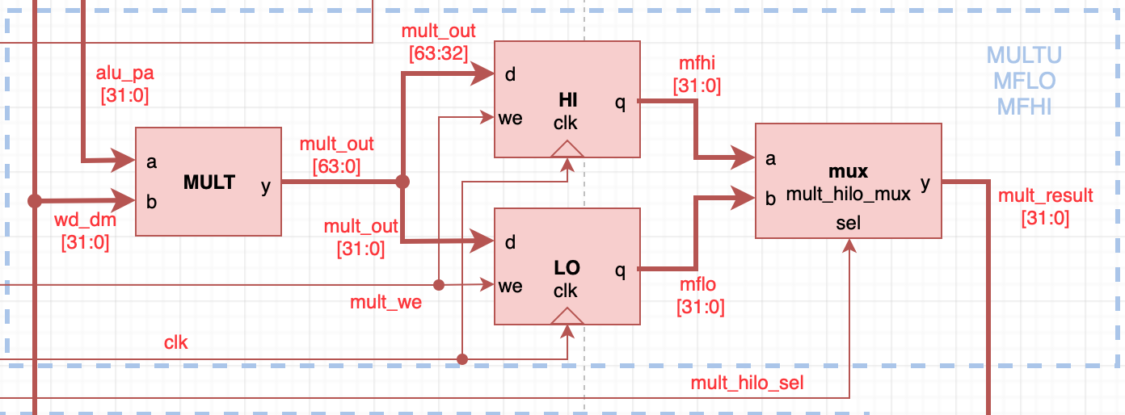

Figure 1. MULTU, MFHI, MFLO microarchitecture

Table 1. Decoding Function Field for MULTU, MFHI, MFLO

|  |  |  |
| --- | --- | --- |
| **Instruction** | **Function Field** | **Relevant Control Signals** |
| MULTU | 011001 | mult_we = 1  mult_hilo_sel = 0  mult_shift_result = 0  rf_mult_shift_wd_mux = 1 |
| MFHI | 010000 | mult_we = 0  mult_hilo_sel = 0  mult_shift_result = 0  rf_mult_shift_wd_mux = 1 |
| MFLO | 010010 | mult_we = 0  mult_hilo_sel = 1  mult_shift_result = 0  rf_mult_shift_wd_mux = 1 |

**SLL, SRL**

Implementing SLL and SRL also required a new module called “shifter”. The design for this module was given in Part 1 of this assignment. This logic for this module is simple: an input d from output rd2 of the register file is shifted left or right a certain amount of bits depending on an input control signal “sl_or_sr” and a shift amount input called “shamt”. The output “y” is forwarded to a mux that picks between forwarding the output of the shifter module or the HI and LO registers (selected by another mux “mult_hilo_mux” explained in the MULTU, MFHI, MFLO section above). Figure 2 shows a diagram of this microarchitecture below. The implementation in code followed the diagram we designed in Part 1 of this assignment.

The relevant control signals for SLL and SRL are “sl_or_sr” and “mult_shift_mux”. “sl_or_sr” determines whether a shift left or shift right is performed. “sl_or_sr” is 0 when a SLL operation is executed and 1 for a SRL operation. Since these instructions store the result into the register file, “mult_shift_mux” is 1 to forward the output of the shift module to the register file.

Similar to the MULTU, MFHI, and MFHI instructions, the auxiliary decoder in the control unit contains the logic for these control signals. Again, since these are R-Type instructions, further decoding using the function field is necessary since the opcode of an R-Type instruction is just 0. Table 2 below shows how the function field for SLL and SRL are decoded. For a full view of the control unit truth table that shows all control signals output by the control unit, please see Appendix B.

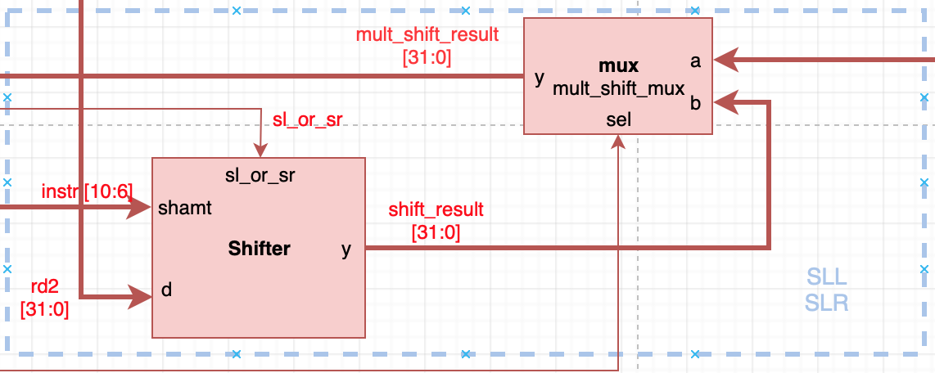

Figure 2. SLL and SRL microarchitecture

Table 2. Decoding Function Field for SLL, SRL instructions

|  |  |  |
| --- | --- | --- |
| **Instruction** | **Function Field** | **Relevant Control Signals** |
| SLL | 000000 | sl_or_sr = 0  mult_shift_result = 1  rf_mult_shift_wd_mux = 1 |
| SRL | 000010 | sl_or_sr = 1  mult_shift_result = 1  rf_mult_shift_wd_mux = 1 |

**JR**

Implementing JR was simple as only one additional mux was needed. Furthermore, the logic for this mux was already given to us in Assignment 5 making our task even easier. We simply instantiated another mux2 object and attached it to the input of the program counter register (pc_reg). The inputs of the mux were connected to the output of the given pc_jmp_mux and output rd1 of the register file. In this way, the new mux would select data (typically an address for an instruction in instruction memory) from a register to store into the program counter with a new control signal “pc_jr_sel”. Figure 3 shows the microarchitecture for JR.

“pc_jr_sel” is the only relevant control signal for JR. It is given a 1 to select the data from from a register from the register file during execution. This control signal is provided by the auxiliary decoder. Since JR is an R-Type instruction, it must be decoded using the function field, not the opcode. Table 3 shows how this function field was decoded. For a full view of the control unit truth table that shows all control signals output by the control unit, please see Appendix B.

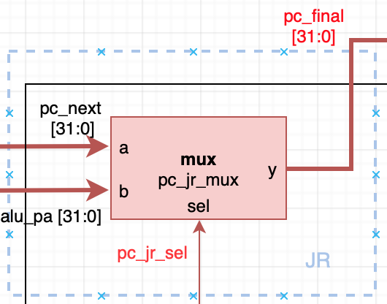

Figure 3. Microarchitecture for JR instruction

Table 3. Decoding Function Field for MULTU, MFHI, MFLO

|  |  |  |
| --- | --- | --- |
| **Instruction** | **Function Field** | **Relevant Control Signals** |
| JR | 001000 | pc_jr_sel = 1 |

**JAL**

Implementing JAL was similarly simple to JR. No new modules were needed. To implement this, we created two new muxes in the datapath module and connected them according to our design from Part 1 of Assignment 7. One mux is connected to the input for read address port of the register file. Another mux is connected to the input port for write data of the register file via another mux used for selecting between this data and data from MFHI, MFLO, SLL, and SRL. Figure 2 shows the microarchitecture for this instruction.

The relevant control signals for JAL are “rf_wa_jal_sel” and “rf_wd_jal_sel”. “rf_mult_shift_wd_mux” is also vital to ensuring that the program counter + 4 is correctly forwarded to the write data port of the register file. Furthermore, “jump” from Assignment 5 which controls the output of pc_jmp_mux is also relevant as it controls the forwarding of the jump address from the address field of the JAL instruction to the program counter register. “rf_wa_jal_sel” must be 1 to forward the address of register 31 to the write address port of the register file. “rf_wd_jal_sel” must be 1 to forward program counter + 4 to the write data port of the register file. Since JAL is a J-Type instruction, its control signals are provided by the main decoder. JAL’s opcode provides the necessary decoding ability. Table 4 shows how the opcode is decoded and the relevant control signal values.

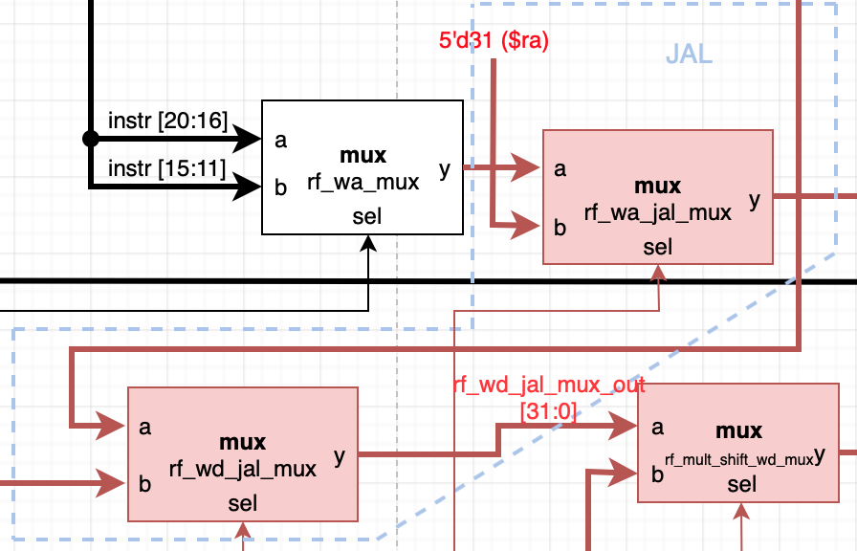

Figure 4. Microarchitecture for JAL instruction

Table 4. Decoding Opcode Field for JAL instructions

|  |  |  |
| --- | --- | --- |
| **Instruction** | **Opcode Field** | **Relevant Control Signals** |
| JAL | 000011 | rf_wd_jal_sel = 1  rf_wa_jal_sel = 1  rf_mult_shift_wd_sel = 0  jump = 1 |

**Functional Verification**

The next task we focused on was validating the design of the newly implemented MIPs instructions. To accomplish this, we borrowed most of the testbench from Assignment 5. We made small modifications like showing the output of the MFHI and MFLO instructions through the mult_result bus, showing the output of SLL and SRL instructions through the shift_result bus, and showing the new control signals on the waveform output. We also changed the function that created a clock signal for the datapath as the clock would need to tick until the program finished executing. The program was considered finished when the program counter reached 0x000c. We also used outputs given from the Assignment 5 testbench like pc_current, alu_out, and others to further verify correct program execution.

Next, we assembled the given sample driver MIPS program and added the resulting memfile.dat as a simulation source and performed the simulation. To confirm that the design was working correctly, we compared the output waveforms through eyeballing. Examining these outputs and the execution of the program in the MARS assembler tool confirmed that our design was correct. For example, we checked that instructions like JAL and JAR correctly performed a jump to the target program address in both the waveform and in MARS. Another example, we checked that n was decremented each time a loop in the factorial loop occurred. Finally, we also verified that the correct value of n! was calculated with the MULTU instruction using the mult_result bus. With input n = 0x4, we recorded n! = 0x18 which correctly validated our designs. The "Simulation Log" section of the report contains screenshots that show how we functionally verified our design with our eyeballing testbench.

Here is an example set of steps we used to verify correct execution of an instruction:

1. Look at how an instruction behaves in MARS when executed. Identify affected registers or memory segments affected by the instruction.
2. Identify the necessary control signals for the instruction in the Control Unit Truth Table (Appendix B)
3. Find the corresponding instruction in the simulation waveform (Figure 5) using the program counter.
4. Compare the waveform outputs for the relevant instruction and the output control signals with the control unit truth table. (For example, examine output bus “mult_result” during a MFLO instruction and mult_hilo_sel value).

We found that the given sample program did not test SLL or SRL. To test SLL and SRL, we also wrote a sample assembly MIPS program, compiled it, and ran it through the testbench. The code for this is shown in Appendix C under *sll.asm* and *sll.dat*. Although this part was not required, we felt it necessary to verify that our design worked correctly before advancing any further. Figure 8 in the "Simulation Log" section shows the waveforms for this program execution and a brief explanation of how this was verified. This portion of the functional verification can easily be recreated by importing the *sll.dat* file as a simulation source and executing a simulation in Vivado.

Finally, after examining the output of the simulation, we were satisfied with the functional verification of our design. We then moved on to hardware validation. This is explained in the “Hardware Validation” section of the report.

### Simulation Log

Figure 5. Entire simulation waveform including new control signals, mult_result, shift_result. Although this screenshot is difficult to read in its current zoomed out state, the final execution results are shown on the right side of the screenshot. Program execution ends at 0x0000000c with the final result of n! = 18 shown on the alu_out bus. A zoomed in view is present in the Figure below.

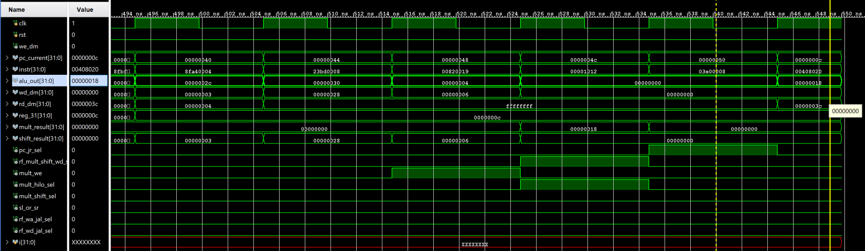

Figure 6. Waveform at the end of program execution showing correct result in alu_out as n! is moved into $s0 with instruction *add $16, $2, $0*

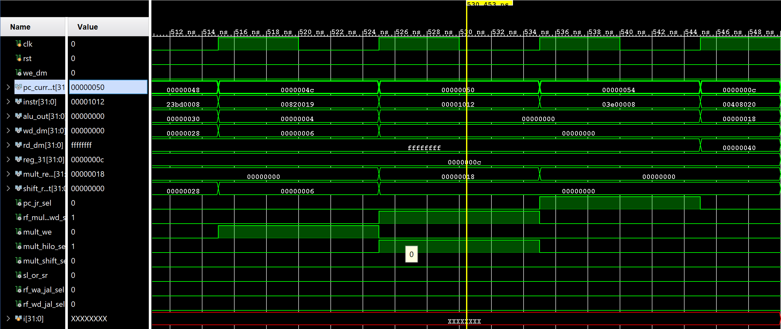

Figure 7. Waveform showing MULTU, MFLO, and MFHI instructions with their respective control signals and mult_result output. Pc_current = 0x0000004c corresponds with instruction *multu $a0, $v0* pc_current = 0x00000050 corresponds with instruction *mflo $v0*. For MULTU, we verified that mult_we was 1 to ensure the output of the operating was saved to the HI and LO registers. We verified that the correct data was calculated and stored by observing the results of the MFLO instruction. MFLO put 0x18 on the mult_result bus as shown in the waveforms and was verified in the MARS assembly tool. MFLO also required mult_hilo_sel = 1, rf_mult_wd_shift_sel = 1 to ensure the data was correctly forwarded to the register file. These are also correctly shown on the waveform.

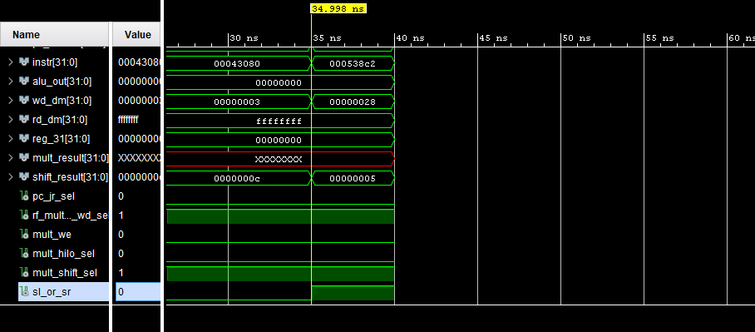

Figure 8. Waveforms depicting the SLL, and SLR instructions. For functionality of the shifter module to shift bits to the left a provided amount, sl_or_sr must be set to 0. Otherwise, to shift bits to the right a certain amount, sl_or_sr must be set to 1. The shift amount is encoded in the “shamt” field for R-Type instructions.

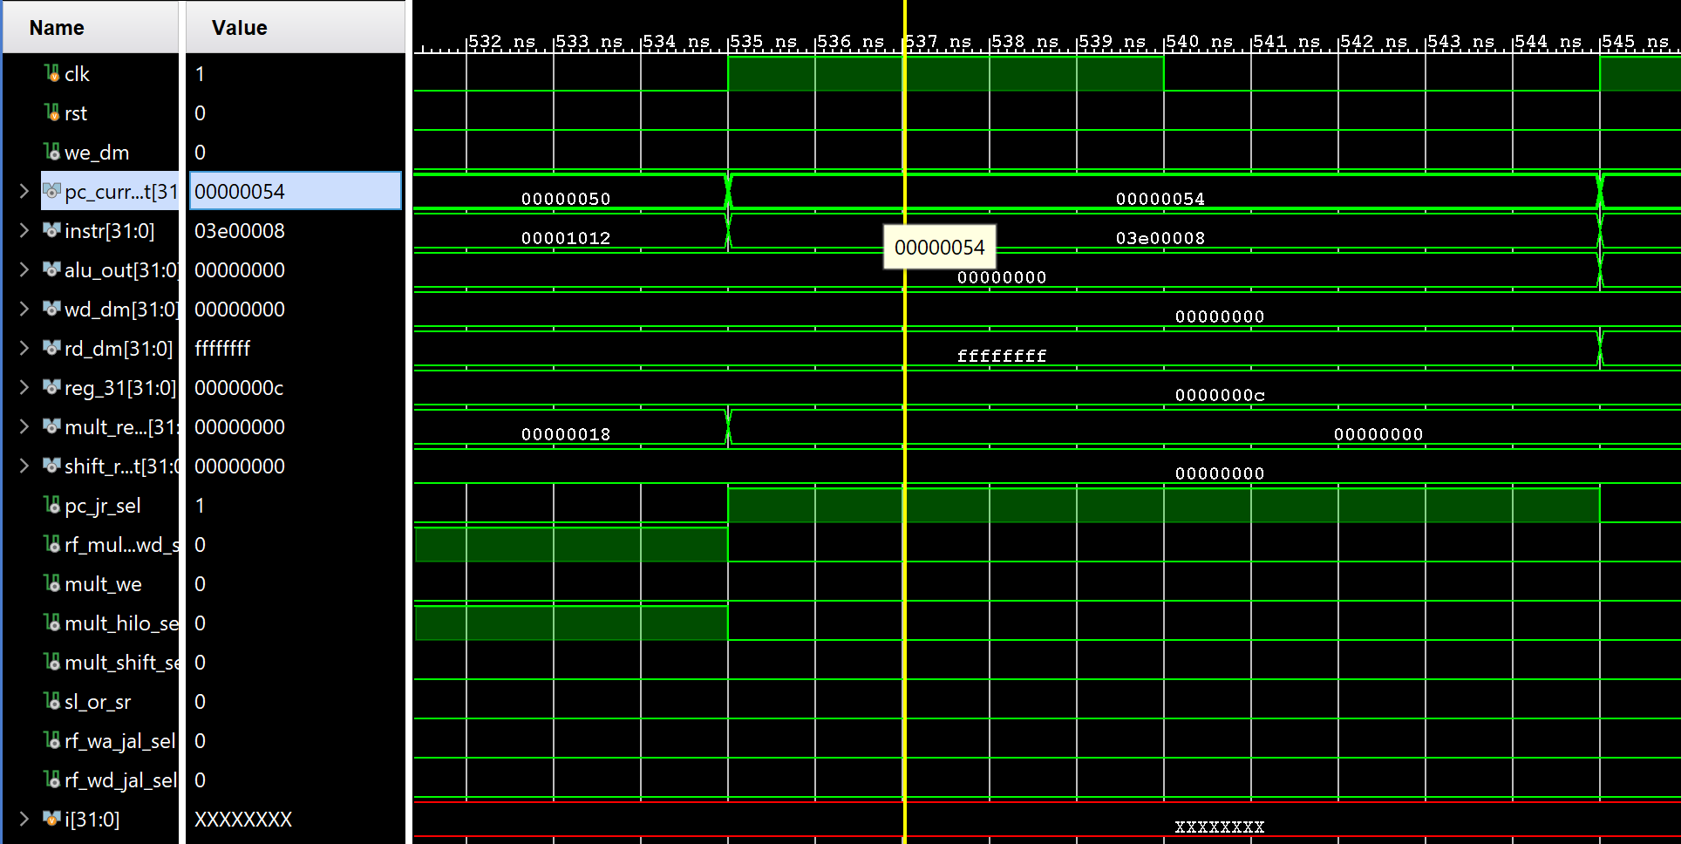

Figure 9. Waveforms depicting the JR instruction *jr $ra*. For this instruction to execute properly, the address data from a register in the register file must be forwarded via the pc_jr_mux multiplexor to the program counter register. According to our design pc_jr_sel must be 1 to enable this functionality. The waveform correctly shows pc_jr_sel = 1for instr = 0x03e00008.

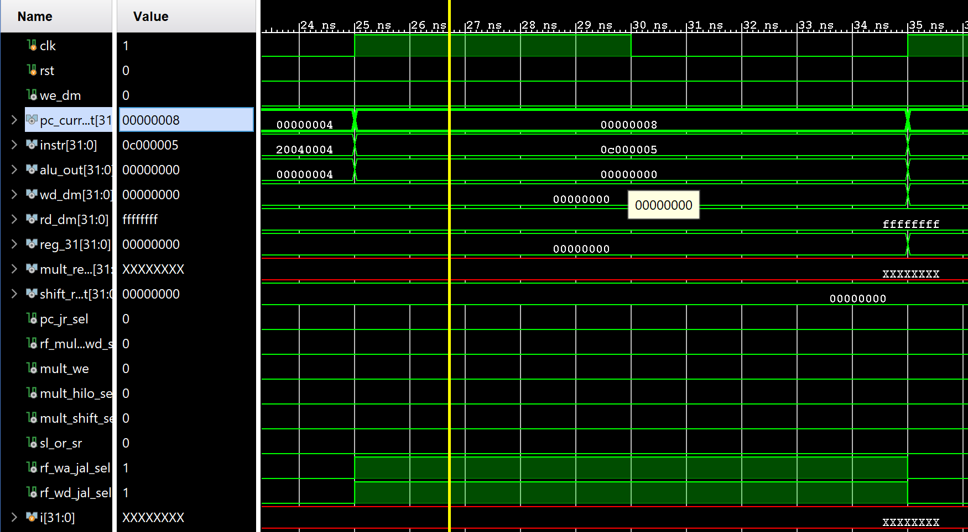

Figure 10. This waveform shows output of a JAL instruction, *jal factorial*. rf_wd_jal_sel and rf_wa_jal_sel are both 1 for instr = 0x0c000005 indicating that this execution is being executed correctly according to our control unit design. This was verified with the data in Appendix B.

### 

### Hardware Validation

The task of validating our design on a hardware FPGA device involved creating a testing environment with modules to drive the MIPS processor and connecting pins on the Basys3 board with inputs and outputs in our design. Thankfully, most of the required components were reusable from Assignment 5. The code for the testing environment is listed in Appendix C under mips_fpga.v. The configuration of the switches, LEDs, and push buttons on the Basys3 board are explained in Table 5. Switches 8 through 5 control what data is shown on the 7-segment display. Table 6 explains how to configure these switches to show specific data. Table 7 shows a quick reference of the instructions being executed on the Basys3 FPGA board and their respective program counter value. Figure 11 shows a real-world visual of how pins was connected on the Basys3 board. Figure 12 shows a diagram of the hardware validation environment. Appendix D contains pictures of the FPGA validation with brief descriptions of how some instructions were validated.

An example is presented below to explain how an instruction was validated on the Basys3 board:

**mflo $2 (Machine code: 0x00001012)** See Figure 21 and 22 in Appendix D for pictures of this instruction.

1. Change switches 8 through 5 to display the program counter (SW8-SW5 = 1000)
2. Press the push button that controls the clock to advance the program counter and program execution until the correct instruction is reached. Use Table 7 for a quick reference of which program counter value corresponds with a particular instruction. (See Figure 21 in Appendix D for this example)
3. Change switches 8 through 5 to display the machine code (SW8-SW5 = 0010, 0011)
   1. Verify that the machine code matches the instruction in Table 7
4. Verify that the correct LEDs are lit up for the relevant control signals for the instruction. Use Table 5 to reference which LEDs should be lit. (For MFLO, mult_hilo_sel = 1, rf_mult_shift_wd_sel = 1, mult_shift_sel = 0) [See Figure 21 in Appendix D for this example]
5. If the instruction performs some calculation, verify the contents are output on the relevant bus (In this example, check that mult_result = 0x2 for the first appearance of this instruction. Note that since this is a loop, the output of this instruction changes with each appearance) [See Figure 22 in Appendix D for this example]

These steps were performed for all new instructions in the sample program: JAL, JR, and MULTU.

Table 5. Hardware configuration (leds, buttons etc.)

|  |  |
| --- | --- |
| **Hardware Device** | **What It Does** |
| SW8-SW0 | These switches make up all switches input to the top module of mips_fpga. |
| SW8-SW5 | These switches are input into a special multiplexor used for controlling which data is shown on the seven-segment display. Table 6 below shows how each configuration of these switches shows specific data. |
| SW4-SW0 | These switches are used to choose which register to show data from. Note that data from a register is not shown unless SW8-SW5 are properly configured to display data from registers. |
| BTNC (Center push button on Basys3) | This button controls the clock signal that is input to all registers inside of the MIPS processor. |
| BTNL (Left push button on Basys3) | This button controls the reset signal for the clock generator, led multiplexor, and the program counter inside the datapath of the MIPS processor. Note that this reset signal does not clear data from the register file within the datapath of the MIPS processor. |
| Seven-Segment Display | This display shows selected data according to SW8-SW5. Data is shown in hex. See Table 2 to see how to display specific data. |
| LD0 (LED above SW0) | This LED shows the status of the write enable data memory (we_dm) signal. This LED should light up when we_dm is high, which happens when a save word instruction is being executed. |
| LD1 (LED above SW1) | This LED shows the status of the program counter jump register select (pc_jr_sel) signal. This LED should light up when a JAL instruction is executed, indicating that the respective mux is outputting data from a given register address. |
| LD2 (LED above SW2) | This LED shows the status of the select signal for the rf_wd_jal_sel mux (rf_wd_jal_sel). When a JAL instruction is executed, this LED should light up indicating that data from the program counter register + 4 is forwarded to the register file. |
| LD3 (LED above SW3) | This LED shows the status of the select signal for the rf_wa_jal_sel mux (rf_wa_jal_sel). When a JAL instruction is executed, this LED should light up indicating that register 31 in the register file is being addressed through this mux. |
| LD4 (LED above SW4) | This LED shows the status of the select signal (rf_mult_shift_wd_sel) for the mux that picks between forwarding data from a MFHI, MFLO, SLL, SRL instruction or from other instructions. This LED lights up when MFHI, MFLO, SLL, or SRL are executed indicating the resultant data is written to the register file. |
| LD5 (LED above SW5) | This LED shows the status of the write enable signal for a MULTU instruction (mult_we). This LED should light up when a MULTU instruction is executing indicating data is being stored to the HI and LO registers. |
| LD6 (LED above SW6) | This LED shows the status of the select signal (mult_hilo_sel) for the mult_hilo_mux mux. This LED should light up when a MFLO is executed. Note that this LED doesn’t light up for a MFHI instruction as this signal determines whether HI or LO data appears on the respective bus. |
| LD7 (LED above SW7) | This LED shows the status of the select signal (mult_shift_sel) for the mult_shift_mux mux. This LED lights up when a SLL or SRL instruction is executed. Note that this LED does not light up for a MFLO or MFHI instruction as this signal as a low for this signal picks data output from the HI or LO registers. |
| LD8 (LED above SW8) | This LED shows the status of the control signal (sl_or_sr) for the shifter module. A 0 indicates a SLL operation while a 1 indicates a SRL operation. Therefore, this LED only lights up when a SRL operation is executed. |

Table 6. Switch[8:5] configuration to choose which data to display on the 7-segment display

|  |  |
| --- | --- |
| **Switches[8:5]** | **Data Displayed** |
| 0000 | Lower half word of selected register by SW4-SW0 |
| 0001 | Upper half word of selected register by SW4-SW0 |
| 0010 | Lower half word of instruction being executed |
| 0011 | Upper half word of instruction being executed |
| 0100 | Lower half word of output of ALU |
| 0101 | Upper half word of output of ALU |
| 0110 | Lower half word of data to be written to memory |
| 0111 | Upper half word of data to be written to memory |
| 1000 | Lower half word of program counter |
| 1001 | Upper half word of program counter |
| 1010 | Lower half of output of a MFLO or MFHI instruction |
| 1011 | Upper half of output of a MFLO or MFHI instruction |
| 1100 | Lower half of output of a SLL or SRL instruction |
| 1101 | Upper half of output of a SLL or SRL instruction |

Table 7. Assembly Code, Machine Code, Program Counter Table used to compare results of FPGA validation

|  |  |  |
| --- | --- | --- |
| **Assembly Code** | **Machine Code** | **Program Counter** |
| addi $sp, $0, 48 | 0x201d0030 | 0x0000 |
| addi $a0, $0, 4 | 0x20040004 | 0x0004 |
| jal factorial | 0x0c000005 | 0x0008 |
| add $s0, $v0, $0 | 0x00408020 | 0x000c |
| j end | 0x08000016 | 0x0010 |
| addi $sp, $sp, -8 | 0x23bdfff8 | 0x0014 |
| sw $a0, 4($sp) | 0xafa40004 | 0x0018 |
| sw $ra, 0($sp) | 0xafbf0000 | 0x001c |
| addi $t0, $0, 2 | 0x20080002 | 0x0020 |
| slt $t0, $a0, $t0 | 0x0088402a | 0x0024 |
| beq $t0, $0, else | 0x11000003 | 0x0028 |
| addi $v0, $0, 1 | 0x20020001 | 0x002c |
| addi $sp, $sp, 8 | 0x23bd0008 | 0x0030 |
| jr $ra | 0x03e00008 | 0x0034 |
| addi $a0, $a0, -1 | 0x2084ffff | 0x0038 |
| jal factorial | 0x0c000005 | 0x003c |
| lw $ra, 0($sp) | 0x8fbf0000 | 0x0040 |
| lr $a0, 4($sp) | 0x8fa40004 | 0x0044 |
| addi $sp, $sp, 8 | 0x23bd0008 | 0x0048 |
| multu $a0, $v0 | 0x00820019 | 0x004c |
| mflo $v0 | 0x00001012 | 0x0050 |
| jr $ra | 0x03e00008 | 0x0054 |

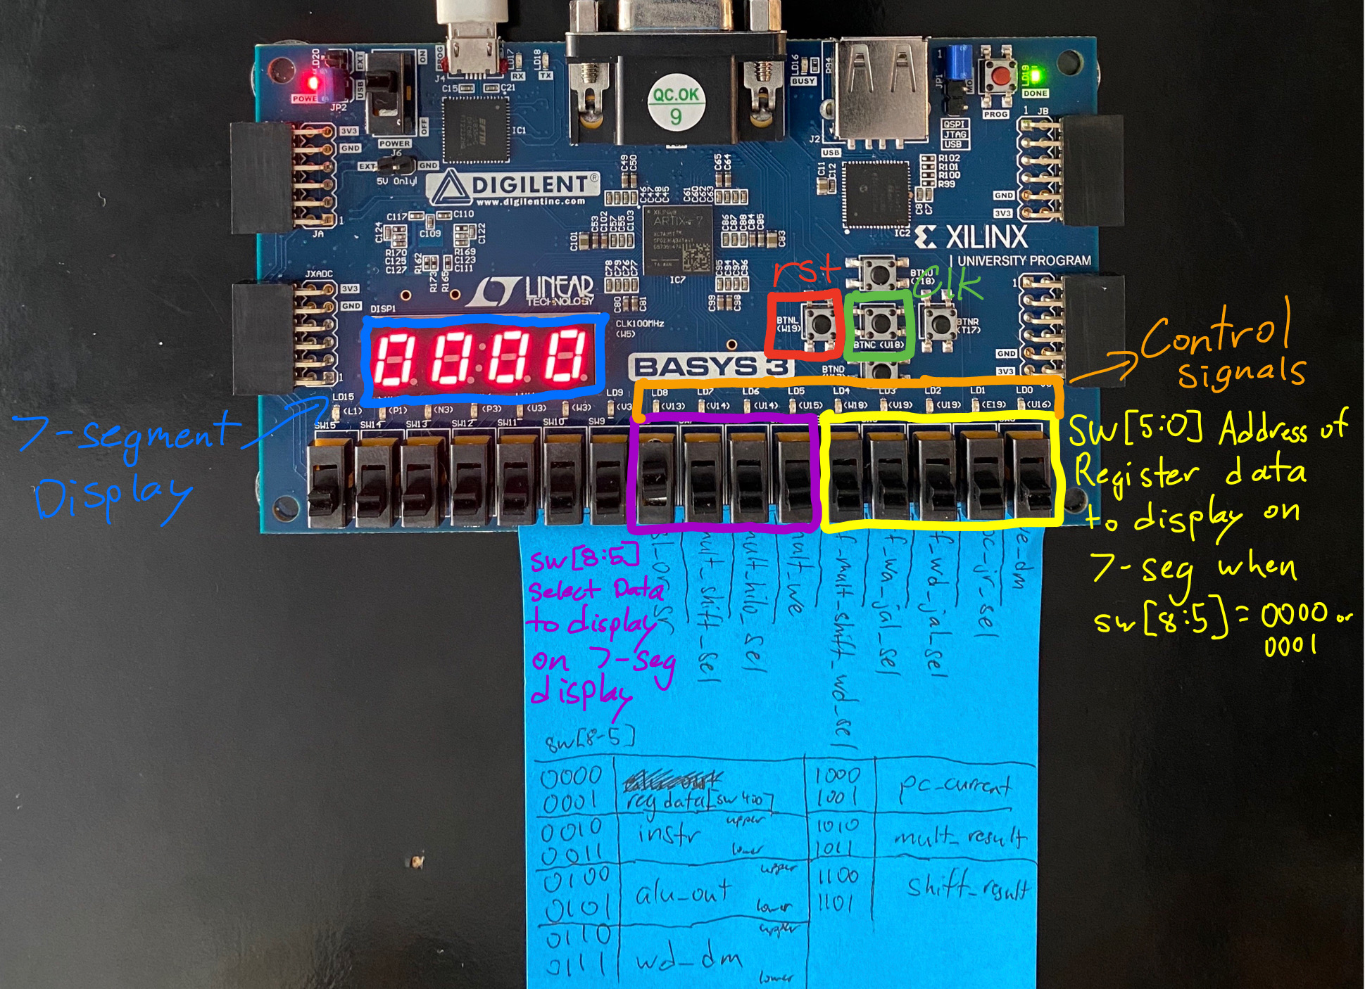

Figure 11. This picture shows how each hardware input and output were configured. The first five switches in yellow on the right side of the board control which data is shown on the 7-segment display from a particular register in the register file. The switches in purple control which data is shown on the 7-segment display according to the table shown on the Post-It and in Table 6. The middle push-button in green controls the clock for the datapath. The left push-button in red controls the reset signal to the program counter register. Note that this reset signal does not clear the register file of its contents. The attached Post-It attempts to label all the control signals that are shown on the respective LEDs. The LEDs going from right to left show the following signals: we_dm, pc_jr_sel, rf_wd_jal_sel, rf_wa_jal_sel, rf_mult_shift_wd_sel, mult_we, mult_hilo_sel, mult_shift_sel, sl_or_sr.

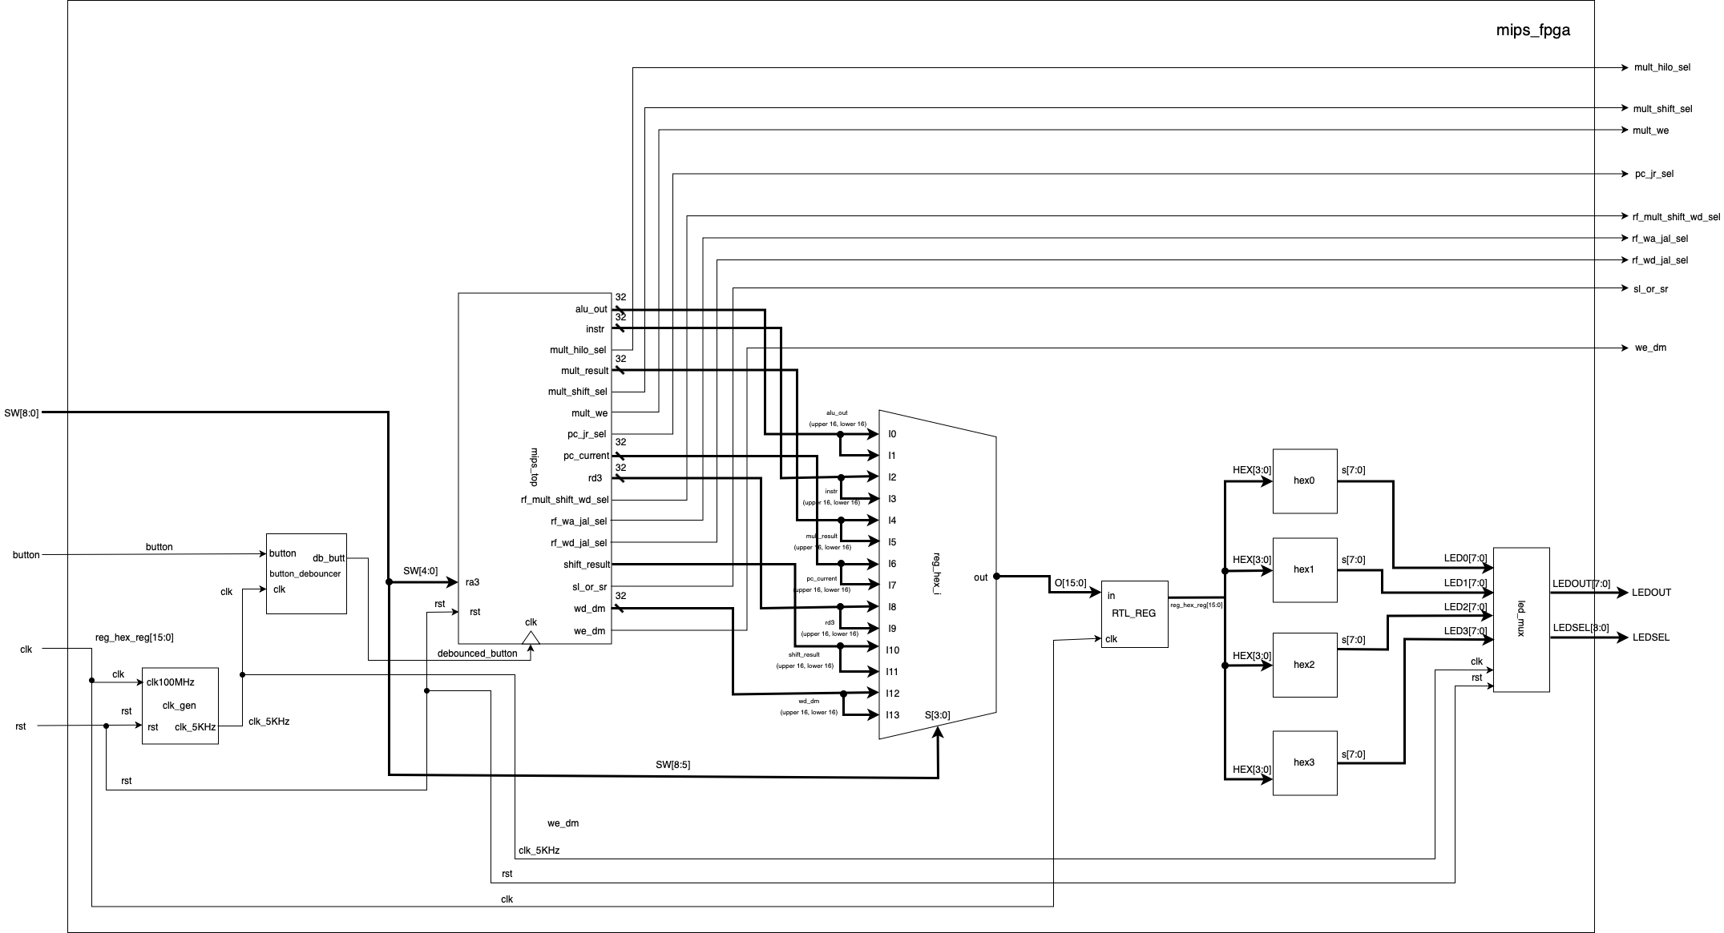

Figure 12. Hardware validation environment drawn by team

### Accomplished Procedures

1. *Implemented new datapath design to support MULTU, MFLO, MFHI, JAL, JR, SLL, SRL*
2. *Implemented new control unit logic to support MULTU, MFLO, MFHI, JAL, JR, SLL, SRL*
3. *Functionally validated processor design with an eyeballing testbench*
4. *Validated processor design on Basys3 FPGA hardware*

### Conclusion

This was an extremely work intensive assignment despite being split into two parts. I think the assignment would have been simpler to digest had it been split into three parts: 1. Design of extended datapath, 2. Functional verification, and 3. Hardware validation. Nevertheless, it was an assignment that taught us incredibly valuable lessons about designing microarchitecture for a processor to support new instruction. This small glimpse into the development process for a more complicated processor was exciting to say the least. We are now armed with the knowledge to design a datapath that supports even more instructions to support more complicated programs.

Another takeaway from this assignment was that no knowledge of the high level programs targeting our processor was necessary. That is, if we designed our processor to properly execute instructions like MULTU, JAL, or JR, any program can be run on our processor. The assembler (in this case) offers a level of abstraction that allowed us to focus on the design of the various modules necessary for new instructions. This made our job as a computer engineer in training much simpler. This is akin to a processor developer like ARM or Intel designing a processor that can run any program so long as the compiler and assembler tools properly convert a high level language into assembly instructions that the processor can execute.

Throughout the implementation process, it was important to be careful as one small mistake could cause problems further down the line. An example of this was when made a mistake in the control unit logic for the MULTU instruction. We mistakenly added the opcode for a MULT instruction instead of a MULTU instruction as a case in the control unit to output control signals for. This caused our simulation to crash when it encountered a MULTU instruction as there was no support for its opcode. After a day of troubleshooting, we discovered our small mistake and correctly righted the ship. Other small mistakes like missing a 1 in the control unit truth table had great potential to throw off our whole design and testing efforts. Nevertheless, we persevered and successfully completed all tasks and requirements for this assignment. Though future assignments sound more complicated, we think we’re up to the task.

### Appendix A: Diagrams

### 

Figure 13a. Although this full datapath diagram was presented in the report Part 1 of this assignment, it is included here as a reference with small updates to signal wires as they appear in our code.

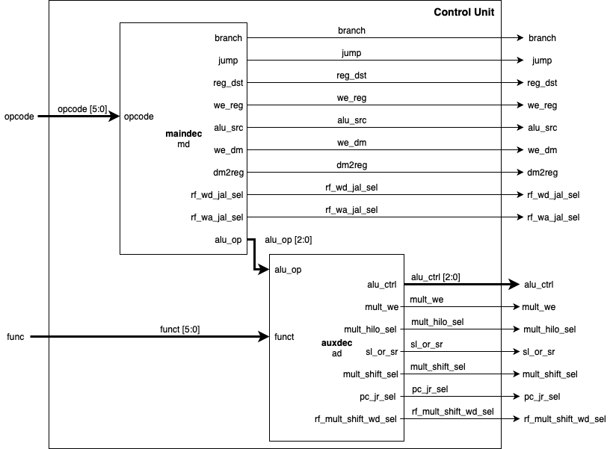

Figure 13b. Although this control unit diagram was presented in the report for Part 1 of this assignment, it is included here for reference. It’s vital to understand where each control signal comes from to understand the control unit logic design.

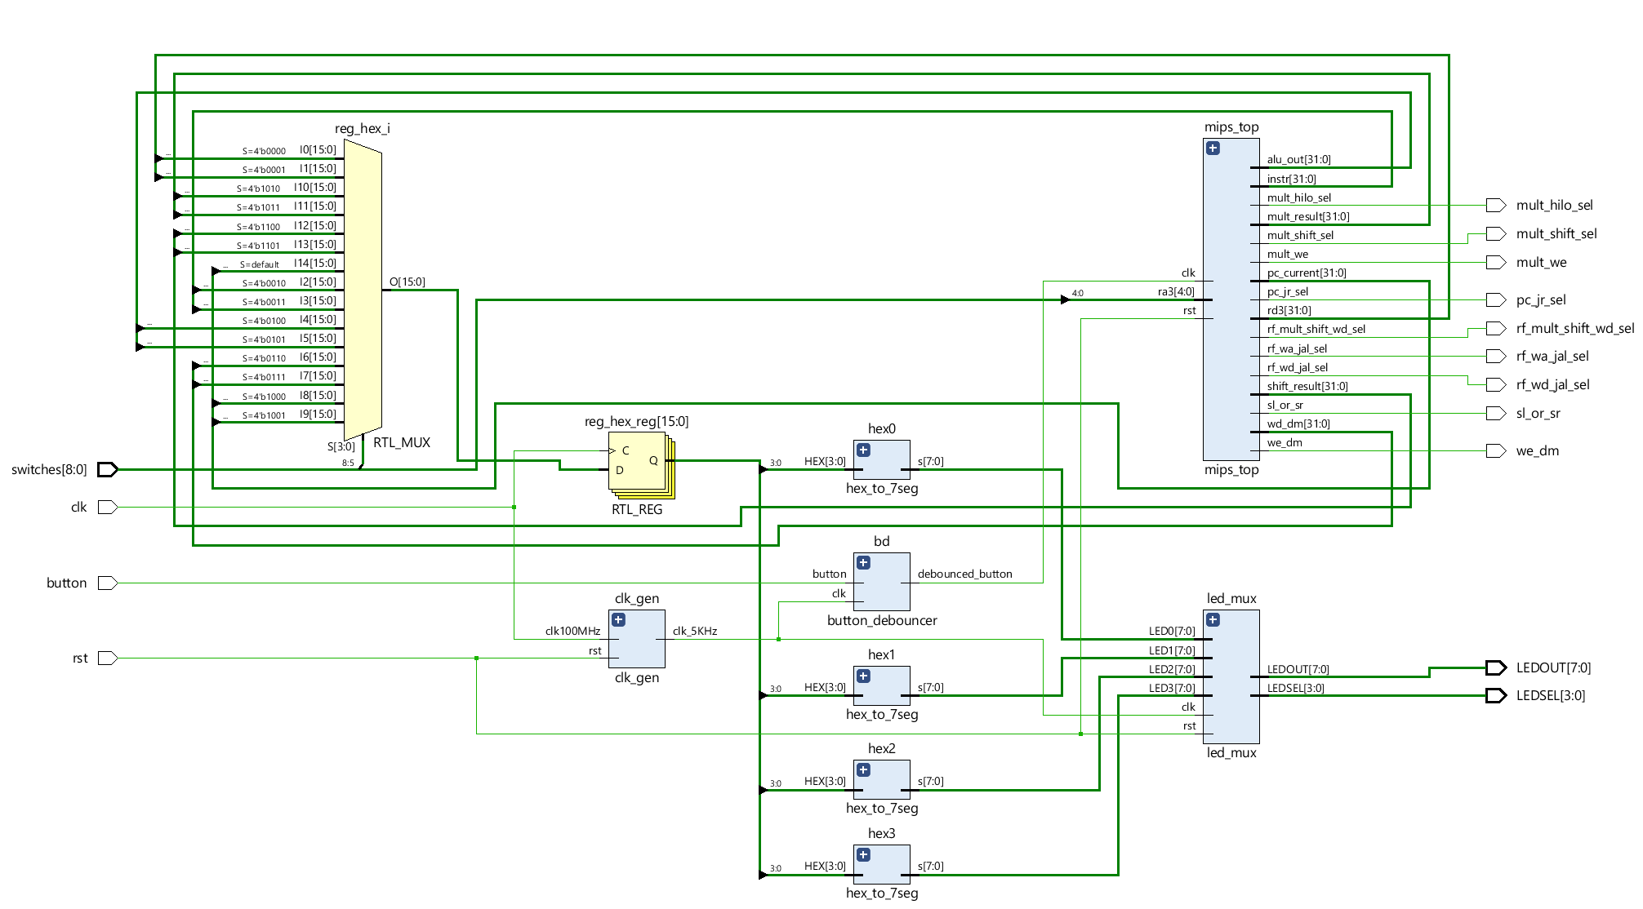

Figure 14. A cleaner diagram of hardware validation environment generated by Vivado. Included for reference only.

### Appendix B: Control Unit Truth Table

Table 8. Control Unit (Auxiliary Decoder)

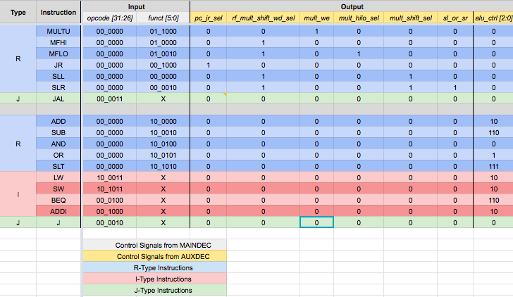

Table 9. Control Unit (Main Decoder)

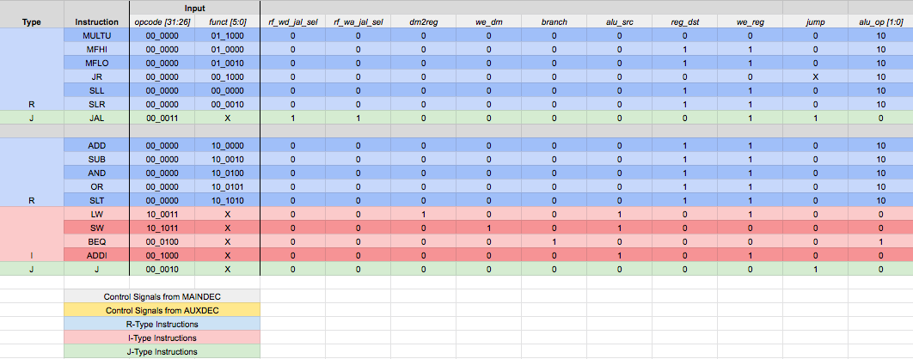

### Appendix C: Code

|  |
| --- |
| **assignment _7_test_code.asm** |
| main:  addi $sp, $0, 48  addi $a0, $0, 4 # set arg  jal factorial # compute the factorial  add $s0, $v0, $0 # move result into $s0 NOTE: Program should end here  j end  factorial:  addi $sp, $sp, -8 # make room on stack  sw $a0, 4($sp) # store $a0  sw $ra, 0($sp) # store $ra  addi $t0, $0, 2 # $t0 = 2  slt $t0, $a0, $t0 # a <= 1 ?  beq $t0, $0, else # no - goto else  addi $v0, $0, 1 # yes - return 1  addi $sp, $sp, 8 # restore $sp  jr $ra # return  else:  addi $a0, $a0, -1 # n = n - 1  jal factorial # recursive call  lw $ra, 0($sp) # restore $ra  lw $a0, 4($sp) # restore $a0  addi $sp, $sp, 8 # restore $sp  multu $a0, $v0 # n * factorial(n-1)  mflo $v0 # mv result into $v0  jr $ra  end: |

|  |
| --- |
| **memfile.dat (created from assignment_7_test_code.asm)** |
| 201d0030  20040004  0c000005  00408020  08000016  23bdfff8  afa40004  afbf0000  20080002  0088402a  11000003  20020001  23bd0008  03e00008  2084ffff  0c000005  8fbf0000  8fa40004  23bd0008  00820019  00001012  03e00008 |

|  |
| --- |
| **mips_fpga.v** |
| module mips_fpga (  input wire clk,  input wire rst,  input wire button,  input wire [8:0] switches,  output wire we_dm,  output wire [3:0] LEDSEL,  output wire [7:0] LEDOUT,    // New outputs  output wire pc_jr_sel,  output wire rf_mult_shift_wd_sel,  output wire mult_we,  output wire mult_hilo_sel,  output wire mult_shift_sel,  output wire sl_or_sr,  output wire rf_wa_jal_sel,  output wire rf_wd_jal_sel  );  reg [15:0] reg_hex;  wire clk_sec;  wire clk_5KHz;  wire clk_pb;  wire [7:0] digit0;  wire [7:0] digit1;  wire [7:0] digit2;  wire [7:0] digit3;  wire [31:0] pc_current;  wire [31:0] instr;  wire [31:0] alu_out;  wire [31:0] wd_dm;  wire [31:0] rd_dm;  wire [31:0] dispData;    // New wires  wire [31:0] mult_result;  wire [31:0] shift_result;  clk_gen clk_gen (  .clk100MHz (clk),  .rst (rst),  .clk_4sec (clk_sec),  .clk_5KHz (clk_5KHz)  );  button_debouncer bd (  .clk (clk_5KHz),  .button (button),  .debounced_button (clk_pb)  );  mips_top mips_top (  .clk (clk_pb),  .rst (rst),  .ra3 (switches[4:0]),  .we_dm (we_dm),  .pc_current (pc_current),  .instr (instr),  .alu_out (alu_out),  .wd_dm (wd_dm),  .rd_dm (rd_dm),  .rd3 (dispData),    // New outputs to 7-seg display  .mult_result (mult_result),  .shift_result (shift_result),    // New outputs to LED  .pc_jr_sel (pc_jr_sel),  .rf_mult_shift_wd_sel (rf_mult_shift_wd_sel),  .mult_we (mult_we),  .mult_hilo_sel (mult_hilo_sel),  .mult_shift_sel (mult_shift_sel),  .sl_or_sr (sl_or_sr),  .rf_wa_jal_sel (rf_wa_jal_sel),  .rf_wd_jal_sel (rf_wd_jal_sel)  );  /*  switches[4:0] are used as the 3rd read address (ra3) of the RF,  dispData is the register contents from the RF's 3rd read port (rd3).  */  hex_to_7seg hex3 (  .HEX (reg_hex[15:12]),  .s (digit3)  );  hex_to_7seg hex2 (  .HEX (reg_hex[11:8]),  .s (digit2)  );  hex_to_7seg hex1 (  .HEX (reg_hex[7:4]),  .s (digit1)  );  hex_to_7seg hex0 (  .HEX (reg_hex[3:0]),  .s (digit0)  );  led_mux led_mux (  .clk (clk_5KHz),  .rst (rst),  .LED3 (digit3),  .LED2 (digit2),  .LED1 (digit1),  .LED0 (digit0),  .LEDSEL (LEDSEL),  .LEDOUT (LEDOUT)  );    /*  switches[8:5] = 0000 : Display lower half word of register selected by switches[4:0]  switches[8:5] = 0001 : Display higher half word of register selected by switches[4:0]  switches[8:5] = 0010 : Display lower half word of 'instr'  switches[8:5] = 0011 : Display higher half word of 'instr'  switches[8:5] = 0100 : Display lower half word of 'alu_out'  switches[8:5] = 0101 : Display higher half word of 'alu_out'  switches[8:5] = 0110 : Display lower half word of 'wd_dm'  switches[8:5] = 0111 : Display higher half word of 'wd_dm'  switches[8:5] = 1000 : Display lower half word of 'pc_current'  switches[8:5] = 1001 : Display higher half word of 'pc_current'    switches[8:5] - 1010 : Display lower half word of 'mult_result'  switches[8:5] - 1011 : Display upper half word of 'mult_result'  switches[8:5] - 1100 : Display lower half word of 'shift_result'  switches[8:5] - 1101 : Display upper half word of 'shift_result'  switch  */    always @ (posedge clk) begin  case ({switches[8:5]})  4'b0000: reg_hex = dispData[15:0];  4'b0001: reg_hex = dispData[31:16];  4'b0010: reg_hex = instr[15:0];  4'b0011: reg_hex = instr[31:16];  4'b0100: reg_hex = alu_out[15:0];  4'b0101: reg_hex = alu_out[31:16];  4'b0110: reg_hex = wd_dm[15:0];  4'b0111: reg_hex = wd_dm[31:16];  4'b1000: reg_hex = pc_current[15:0];  4'b1001: reg_hex = pc_current[31:16];  4'b1010: reg_hex = mult_result[15:0];  4'b1011: reg_hex = mult_result[31:16];  4'b1100: reg_hex = shift_result[15:0];  4'b1101: reg_hex = shift_result[31:16];  default: reg_hex = pc_current[15:0];  endcase  end  endmodule |

|  |
| --- |
| **clk_gen.v** |
| module clk_gen (  input wire clk100MHz,  input wire rst,  output reg clk_4sec,  output reg clk_5KHz  );  integer count1, count2;  always @ (posedge clk100MHz) begin  if (rst) begin  count1 = 0;  count2 = 0;  clk_5KHz = 0;  clk_4sec = 0;  end  else begin  if (count1 == 200000000) begin  clk_4sec = ~clk_4sec;  count1 = 0;  end  if (count2 == 10000) begin  clk_5KHz = ~clk_5KHz;  count2 = 0;  end  count1 = count1 + 1;  count2 = count2 + 1;  end  end  endmodule |

|  |
| --- |
| **button_debouncer.v** |
| module button_debouncer #(parameter depth = 16) (  input wire clk, /* 5 KHz clock */  input wire button, /* Input button from constraints */  output reg debounced_button  );    localparam history_max = (2**depth)-1;  /* History of sampled input button */  reg [depth-1:0] history;  always @ (posedge clk) begin  /* Move history back one sample and insert new sample */  history <= { button, history[depth-1:1] };    /* Assert debounced button if it has been in a consistent state throughout history */  debounced_button <= (history == history_max) ? 1'b1 : 1'b0;  end    endmodule |

|  |
| --- |
| **hex_to_7seg.b** |
| module hex_to_7seg (  input wire [3:0] HEX,  output reg [7:0] s  );  always @ (HEX) begin  case (HEX)  4'h0: s = 8'b11000000;  4'h1: s = 8'b11111001;  4'h2: s = 8'b10100100;  4'h3: s = 8'b10110000;  4'h4: s = 8'b10011001;  4'h5: s = 8'b10010010;  4'h6: s = 8'b10000010;  4'h7: s = 8'b11111000;  4'h8: s = 8'b10000000;  4'h9: s = 8'b10010000;  4'hA: s = 8'b10100000; // b10001000; This is capital A  4'hB: s = 8'b10000011; // b10000000; This is capital B, but is the same as 8  4'hC: s = 8'b10100111; // b11000110; This is capital C  4'hD: s = 8'b10100001; // b11000000; This is capital D, but is the same as 0  4'hE: s = 8'b10000110;  4'hF: s = 8'b10001110;  default: s = 8'b01111111;  endcase  end  endmodule |

|  |
| --- |
| **led_mux.v** |
| module led_mux (  input wire clk,  input wire rst,  input wire [7:0] LED3,  input wire [7:0] LED2,  input wire [7:0] LED1,  input wire [7:0] LED0,  output wire [3:0] LEDSEL,  output wire [7:0] LEDOUT  );  reg [1:0] index;  reg [11:0] led_ctrl;  assign {LEDSEL, LEDOUT} = led_ctrl;    always @ (posedge clk) index <= (rst) ? 2'b0 : (index + 2'd1);    always @ (index, LED0, LED1, LED2, LED3) begin  case (index)  2'd0: led_ctrl <= {4'b1110, LED0};  2'd1: led_ctrl <= {4'b1101, LED1};  2'd2: led_ctrl <= {4'b1011, LED2};  2'd3: led_ctrl <= {4'b0111, LED3};  default: led_ctrl <= {4'b1111, 8'hFF};  endcase  end    endmodule |

|  |
| --- |
| **mips_top.v** |
| module mips_top (  input wire clk,  input wire rst,  input wire [4:0] ra3,  output wire we_dm,  output wire [31:0] pc_current,  output wire [31:0] instr,  output wire [31:0] alu_out,  output wire [31:0] wd_dm,  output wire [31:0] rd_dm,  output wire [31:0] rd3,    // Outputs for simulation  output wire [31:0] mult_result,  output wire [31:0] shift_result,  output wire pc_jr_sel,  output wire rf_mult_shift_wd_sel,  output wire mult_we,  output wire mult_hilo_sel,  output wire mult_shift_sel,  output wire sl_or_sr,  output wire rf_wa_jal_sel,  output wire rf_wd_jal_sel  );  wire [31:0] DONT_USE;  mips mips (  .clk (clk),  .rst (rst),  .ra3 (ra3),  .instr (instr),  .rd_dm (rd_dm),  .we_dm (we_dm),  .pc_current (pc_current),  .alu_out (alu_out),  .wd_dm (wd_dm),  .rd3 (rd3),    // For simulation  .mult_result (mult_result),  .shift_result (shift_result),  .pc_jr_sel (pc_jr_sel),  .rf_mult_shift_wd_sel (rf_mult_shift_wd_sel),  .mult_we (mult_we),  .mult_hilo_sel (mult_hilo_sel),  .mult_shift_sel (mult_shift_sel),  .sl_or_sr (sl_or_sr),  .rf_wa_jal_sel (rf_wa_jal_sel),  .rf_wd_jal_sel (rf_wd_jal_sel)  );  imem imem (  .a (pc_current[7:2]),  .y (instr)  );  dmem dmem (  .clk (clk),  .we (we_dm),  .a (alu_out[7:2]),  .d (wd_dm),  .q (rd_dm),  .rst (rst)  );  endmodule |

|  |
| --- |
| **mips.v** |
| module mips (  input wire clk,  input wire rst,  input wire [4:0] ra3,  input wire [31:0] instr,  input wire [31:0] rd_dm,  output wire we_dm,  output wire [31:0] pc_current,  output wire [31:0] alu_out,  output wire [31:0] wd_dm,  output wire [31:0] rd3,    // Outputs for simulation  output wire [31:0] mult_result,  output wire [31:0] shift_result,  output wire pc_jr_sel,  output wire rf_mult_shift_wd_sel,  output wire mult_we,  output wire mult_hilo_sel,  output wire mult_shift_sel,  output wire sl_or_sr,  output wire rf_wa_jal_sel,  output wire rf_wd_jal_sel  );    wire branch;  wire jump;  wire reg_dst;  wire we_reg;  wire alu_src;  wire dm2reg;  wire [2:0] alu_ctrl;    // New wires Moved all control signals to output of this module to see in waveforms. To remove, uncomment below and remove outputs from module definition  // wire pc_jr_sel;  // wire rf_mult_shift_wd_sel;  // wire mult_we;  // wire mult_hilo_sel;  // wire mult_shift_sel;  // wire sl_or_sr;  // wire rf_wa_jal_sel;  // wire rf_wd_jal_sel;  datapath dp (  .clk (clk),  .rst (rst),  .branch (branch),  .jump (jump),  .reg_dst (reg_dst),  .we_reg (we_reg),  .alu_src (alu_src),  .dm2reg (dm2reg),  .alu_ctrl (alu_ctrl),  .ra3 (ra3),  .instr (instr),  .rd_dm (rd_dm),  .pc_current (pc_current),  .alu_out (alu_out),  .wd_dm (wd_dm),  .rd3 (rd3),  .pc_jr_sel (pc_jr_sel),  .rf_mult_shift_wd_sel (rf_mult_shift_wd_sel),  .mult_we (mult_we),  .mult_hilo_sel (mult_hilo_sel),  .mult_shift_sel (mult_shift_sel),  .sl_or_sr (sl_or_sr),  .rf_wa_jal_sel (rf_wa_jal_sel),  .rf_wd_jal_sel (rf_wd_jal_sel),  .mult_result (mult_result),  .shift_result (shift_result)  );  controlunit cu (  .opcode (instr[31:26]),  .funct (instr[5:0]),  .branch (branch),  .jump (jump),  .reg_dst (reg_dst),  .we_reg (we_reg),  .alu_src (alu_src),  .we_dm (we_dm),  .dm2reg (dm2reg),  .alu_ctrl (alu_ctrl),  .pc_jr_sel (pc_jr_sel),  .rf_mult_shift_wd_sel (rf_mult_shift_wd_sel),  .mult_we (mult_we),  .mult_hilo_sel (mult_hilo_sel),  .mult_shift_sel (mult_shift_sel),  .sl_or_sr (sl_or_sr),  .rf_wa_jal_sel (rf_wa_jal_sel),  .rf_wd_jal_sel (rf_wd_jal_sel)  );  endmodule |

|  |
| --- |
| **imem.v** |
| module imem (  input wire [5:0] a,  output wire [31:0] y  );  reg [31:0] rom [0:63];  initial begin  $readmemh ("memfile.dat", rom);  end  assign y = rom[a];    endmodule |

|  |
| --- |
| **dmem.v** |
| module dmem (  input wire clk,  input wire we,  input wire [5:0] a,  input wire [31:0] d,  output wire [31:0] q,  input wire rst  );  reg [31:0] ram [0:63];  integer n;  initial begin  for (n = 0; n < 64; n = n + 1) ram[n] = 32'hFFFFFFFF;  end    always @ (posedge rst) begin  end  always @ (posedge clk, posedge rst) begin  if (rst) for (n = 0; n < 64; n = n + 1) ram[n] = 32'hFFFFFFFF;  else if (we) ram[a] <= d;  end  assign q = ram[a];    endmodule |

|  |
| --- |
| **controlunit.v** |
| module controlunit (  input wire [5:0] opcode,  input wire [5:0] funct,  output wire branch,  output wire jump,  output wire reg_dst,  output wire we_reg,  output wire alu_src,  output wire we_dm,  output wire dm2reg,  output wire [2:0] alu_ctrl,    // New outputs  output wire pc_jr_sel,  output wire rf_mult_shift_wd_sel,  output wire mult_we,  output wire mult_hilo_sel,  output wire mult_shift_sel,  output wire sl_or_sr,  output wire rf_wd_jal_sel,  output wire rf_wa_jal_sel  );    wire [1:0] alu_op;  maindec md (  .opcode (opcode),  .branch (branch),  .jump (jump),  .reg_dst (reg_dst),  .we_reg (we_reg),  .alu_src (alu_src),  .we_dm (we_dm),  .dm2reg (dm2reg),  .alu_op (alu_op),  .rf_wd_jal_sel (rf_wd_jal_sel),  .rf_wa_jal_sel (rf_wa_jal_sel)  );  auxdec ad (  .alu_op (alu_op),  .funct (funct),  .alu_ctrl (alu_ctrl),  .pc_jr_sel (pc_jr_sel),  .rf_mult_shift_wd_sel (rf_mult_shift_wd_sel),  .mult_we (mult_we),  .mult_hilo_sel (mult_hilo_sel),  .mult_shift_sel (mult_shift_sel),  .sl_or_sr (sl_or_sr)  );  endmodule |

|  |
| --- |
| **maindec.v** |
| module maindec (  input wire [5:0] opcode,  output wire branch,  output wire jump,  output wire reg_dst,  output wire we_reg,  output wire alu_src,  output wire we_dm,  output wire dm2reg,  output wire [1:0] alu_op,    // New outputs  output wire rf_wd_jal_sel,  output wire rf_wa_jal_sel  );  reg [10:0] ctrl;  assign {branch, jump, reg_dst, we_reg, alu_src, we_dm, dm2reg, alu_op, rf_wd_jal_sel, rf_wa_jal_sel} = ctrl;  always @ (opcode) begin  case (opcode)  6'b00_0000: ctrl = 11'b0_0_1_1_0_0_0_10_0_0; // R-type  6'b00_1000: ctrl = 11'b0_0_0_1_1_0_0_00_0_0; // ADDI  6'b00_0100: ctrl = 11'b1_0_0_0_0_0_0_01_0_0; // BEQ  6'b00_0010: ctrl = 11'b0_1_0_0_0_0_0_00_0_0; // J  6'b10_1011: ctrl = 11'b0_0_0_0_1_1_0_00_0_0; // SW  6'b10_0011: ctrl = 11'b0_0_0_1_1_0_1_00_0_0; // LW  6'b00_0011: ctrl = 11'b0_1_0_1_0_0_0_00_1_1; // NEW: JAL  default: ctrl = 11'bx_x_x_x_x_x_x_xx_x_x;  endcase  end  endmodule |

|  |
| --- |
| **auxdec.v** |
| module auxdec (  input wire [1:0] alu_op,  input wire [5:0] funct,  output wire [2:0] alu_ctrl,    // New outputs  output wire pc_jr_sel,  output wire rf_mult_shift_wd_sel,  output wire mult_we,  output wire mult_hilo_sel,  output wire mult_shift_sel,  output wire sl_or_sr  );  reg [9:0] ctrl;  assign {alu_ctrl, pc_jr_sel, rf_mult_shift_wd_sel, mult_we, mult_hilo_sel, mult_shift_sel, sl_or_sr} = ctrl;  always @ (alu_op, funct) begin  case (alu_op)  2'b00: ctrl = 9'b010_0_0_0_0_0_0; // ADD (LW or SW)  2'b01: ctrl = 9'b110_0_0_0_0_0_0; // SUB (BEQ)  default: case (funct)  9'b10_0100: ctrl = 9'b000_0_0_0_0_0_0; // AND  9'b10_0101: ctrl = 9'b001_0_0_0_0_0_0; // OR  9'b10_0000: ctrl = 9'b010_0_0_0_0_0_0; // ADD  9'b10_0010: ctrl = 9'b110_0_0_0_0_0_0; // SUB  9'b10_1010: ctrl = 9'b111_0_0_0_0_0_0; // SLT  9'b01_1001: ctrl = 9'b000_0_0_1_0_0_0; // NEW: MULTU  9'b01_0000: ctrl = 9'b000_0_1_0_0_0_0; // NEW: MFHI  9'b01_0010: ctrl = 9'b000_0_1_0_1_0_0; // NEW: MFLO  9'b00_1000: ctrl = 9'b000_1_0_0_0_0_0; // NEW: JR  9'b00_0000: ctrl = 9'b000_0_1_0_0_1_0; // NEW: SLL  9'b00_0010: ctrl = 9'b000_0_1_0_0_1_1; // NEW: SLR  default: ctrl = 9'bxxx_x;  endcase  endcase  end  endmodule |

|  |
| --- |
| **datapath.v** |
| module datapath (  input wire clk,  input wire rst,  input wire branch,  input wire jump,  input wire reg_dst,  input wire we_reg,  input wire alu_src,  input wire dm2reg,  input wire [2:0] alu_ctrl,  input wire [4:0] ra3,  input wire [31:0] instr,  input wire [31:0] rd_dm,    // New inputs  input wire pc_jr_sel,  input wire rf_mult_shift_wd_sel,  input wire mult_we,  input wire mult_hilo_sel,  input wire mult_shift_sel,  input wire sl_or_sr,  input wire rf_wd_jal_sel,  input wire rf_wa_jal_sel,    output wire [31:0] pc_current,  output wire [31:0] alu_out,  output wire [31:0] wd_dm,  output wire [31:0] rd3,    // Outputs for simulation (to remove, remove from here, remove from mips.v outputs and port connect, mips_top.v outputs and port connect, tb_mips_top.v  output wire [31:0] mult_result,  output wire [31:0] shift_result  );  wire [4:0] rf_wa;  wire pc_src;  wire [31:0] pc_plus4;  wire [31:0] pc_pre;  wire [31:0] pc_next;  wire [31:0] sext_imm;  wire [31:0] ba;  wire [31:0] bta;  wire [31:0] jta;  wire [31:0] alu_pa;  wire [31:0] alu_pb;  wire [31:0] wd_rf;  wire zero;    // Newly added wires  wire [31:0] pc_final;  wire [63:0] mult_out;  wire [31:0] mfhi;  wire [31:0] mflo;  // wire [31:0] mult_result; // Moving to output to display in simulation  // wire [31:0] shift_result; // Moving to output to display in simulation  wire [31:0] mult_shift_result;  wire [31:0] rf_wd_jal_mux_out;  wire [31:0] mux_alu_dm_out;  wire [4:0] rf_wa_mux_out;    assign pc_src = branch & zero;  assign ba = {sext_imm[29:0], 2'b00};  assign jta = {pc_plus4[31:28], instr[25:0], 2'b00};    // --- PC Logic --- //  dreg pc_reg (  .clk (clk),  .rst (rst),  .d (pc_final),  .q (pc_current)  );  adder pc_plus_4 (  .a (pc_current),  .b (32'd4),  .y (pc_plus4)  );  adder pc_plus_br (  .a (pc_plus4),  .b (ba),  .y (bta)  );  mux2 #(32) pc_src_mux (  .sel (pc_src),  .a (pc_plus4),  .b (bta),  .y (pc_pre)  );  mux2 #(32) pc_jmp_mux (  .sel (jump),  .a (pc_pre),  .b (jta),  .y (pc_next)  );  // --- RF Logic --- //  mux2 #(5) rf_wa_mux (  .sel (reg_dst),  .a (instr[20:16]),  .b (instr[15:11]),  .y (rf_wa_mux_out)  );  regfile rf (  .clk (clk),  .we (we_reg),  .ra1 (instr[25:21]),  .ra2 (instr[20:16]),  .ra3 (ra3),  .wa (rf_wa),  .wd (wd_rf),  .rd1 (alu_pa),  .rd2 (wd_dm),  .rd3 (rd3),  .rst (rst)  );  signext se (  .a (instr[15:0]),  .y (sext_imm)  );  // --- ALU Logic --- //  mux2 #(32) alu_pb_mux (  .sel (alu_src),  .a (wd_dm),  .b (sext_imm),  .y (alu_pb)  );  alu alu (  .op (alu_ctrl),  .a (alu_pa),  .b (alu_pb),  .zero (zero),  .y (alu_out)  );  // --- MEM Logic --- //  mux2 #(32) rf_wd_mux (  .sel (dm2reg),  .a (alu_out),  .b (rd_dm),  .y (mux_alu_dm_out)  );    // -- JR Logic --- //  mux2 #(32) pc_jr_mux (  .sel (pc_jr_sel),  .a (pc_next),  .b (alu_pa),  .y (pc_final)  );    // -- MULTU, MFLO, MFHI Logic -- //  mult multu (  .a (alu_pa),  .b (wd_dm),  .y (mult_out)  );    we_dreg #(32) hi (  .d (mult_out[63:32]),  .q (mfhi),  .we (mult_we),  .clk (clk)  );  we_dreg #(32) lo (  .d (mult_out[31:0]),  .q (mflo),  .we (mult_we),  .clk (clk)  );    mux2 #(32) mult_hilo_mux (  .sel (mult_hilo_sel),  .a (mfhi),  .b (mflo),  .y (mult_result)  );    // -- SLL, SLR Logic -- //  shifter #(32) sll_slr_shifter (  .sl_or_sr (sl_or_sr),  .shamt (instr[10:6]),  .d (wd_dm),  .y (shift_result)  );    // -- MULTU or SHIFT MUX -- //  mux2 #(32) mult_shift_mux (  .sel (mult_shift_sel),  .a (mult_result),  .b (shift_result),  .y (mult_shift_result)  );    mux2 #(32) rf_mult_shift_wd_mux (  .sel (rf_mult_shift_wd_sel),  .a (rf_wd_jal_mux_out),  .b (mult_shift_result),  .y (wd_rf)  );    // -- JAL Logic -- //  mux2 #(32) rf_wd_jal_mux (  .sel (rf_wd_jal_sel),  .a (mux_alu_dm_out),  .b (pc_plus4),  .y (rf_wd_jal_mux_out)  );    mux2 #(5) rf_wa_jal_mux (  .sel (rf_wa_jal_sel),  .a (rf_wa_mux_out),  .b (5'd31),  .y (rf_wa)  );    endmodule |

|  |
| --- |
| **dreg.v** |
| module dreg # (parameter WIDTH = 32) (  input wire clk,  input wire rst,  input wire [WIDTH-1:0] d,  output reg [WIDTH-1:0] q  );  always @ (posedge clk, posedge rst) begin  if (rst) q <= 0;  else q <= d;  end  endmodule |

|  |
| --- |
| **adder.v** |
| module adder (  input wire [31:0] a,  input wire [31:0] b,  output wire [31:0] y  );  assign y = a + b;    endmodule |

|  |
| --- |
| **mux2.v** |
| module mux2 #(parameter WIDTH = 8) (  input wire sel,  input wire [WIDTH-1:0] a,  input wire [WIDTH-1:0] b,  output wire [WIDTH-1:0] y  );  assign y = (sel) ? b : a;  endmodule |

|  |
| --- |
| **regfile.v** |
| module regfile (  input wire clk,  input wire we,  input wire [4:0] ra1,  input wire [4:0] ra2,  input wire [4:0] ra3,  input wire [4:0] wa,  input wire [31:0] wd,  output wire [31:0] rd1,  output wire [31:0] rd2,  output wire [31:0] rd3,  input wire rst  );  reg [31:0] rf [0:31];  integer n;    initial begin  for (n = 0; n < 32; n = n + 1) rf[n] = 32'h0;  rf[29] = 32'h100; // Initialze $sp  end    always @ (posedge clk, posedge rst) begin  if (rst) begin  for (n = 0; n < 32; n = n + 1) rf[n] = 32'h0;  rf[29] = 32'h100; // Initialze $sp  end  else if (we) rf[wa] <= wd;  end  assign rd1 = (ra1 == 0) ? 0 : rf[ra1];  assign rd2 = (ra2 == 0) ? 0 : rf[ra2];  assign rd3 = (ra3 == 0) ? 0 : rf[ra3];  endmodule |

|  |
| --- |
| **signext.v** |
| module signext (  input wire [15:0] a,  output wire [31:0] y  );  assign y = {{16{a[15]}}, a};    endmodule |

|  |
| --- |
| **alu.v** |
| module alu (  input wire [2:0] op,  input wire [31:0] a,  input wire [31:0] b,  output wire zero,  output reg [31:0] y  );  assign zero = (y == 0);  always @ (op, a, b) begin  case (op)  3'b000: y = a & b;  3'b001: y = a | b;  3'b010: y = a + b;  3'b110: y = a - b;  3'b111: y = (a < b) ? 1 : 0;  endcase  end  endmodule |

|  |
| --- |
| **mult.v** |
| module mult (  input wire [31:0] a, b,  output wire [63:0] y  );    assign y = a * b;  endmodule |

|  |
| --- |
| **we_dreg.v** |
| module we_dreg # (parameter WIDTH = 32) (  input wire clk,  input wire we,  input wire [WIDTH-1:0] d,  output reg [WIDTH-1:0] q  );  always @ (posedge clk) begin  if (we) q <= d;  else q <= q;  end  endmodule |

|  |
| --- |
| **shifter.v** |
| module shifter # (parameter WIDTH = 32) (  input wire [4:0] shamt,  input wire sl_or_sr,  input wire [WIDTH-1:0] d,  output reg [WIDTH-1:0] y  );    always @ (shamt, sl_or_sr, d) begin  if (sl_or_sr) y = d >> shamt;  else y = d << shamt;  end  endmodule |

|  |
| --- |
| **tb_mips_top.v** |
| module tb_mips_top;  reg clk;  reg rst;  wire we_dm;  wire [31:0] pc_current;  wire [31:0] instr;  wire [31:0] alu_out;  wire [31:0] wd_dm;  wire [31:0] rd_dm;  wire [31:0] reg_31;    // Outputs for simulation  wire [31:0] mult_result;  wire [31:0] shift_result;  wire pc_jr_sel;  wire rf_mult_shift_wd_sel;  wire mult_we;  wire mult_hilo_sel;  wire mult_shift_sel;  wire sl_or_sr;  wire rf_wa_jal_sel;  wire rf_wd_jal_sel;    integer i;    mips_top DUT (  .clk (clk),  .rst (rst),  .we_dm (we_dm),  .ra3 (5'd31),  .pc_current (pc_current),  .instr (instr),  .alu_out (alu_out),  .wd_dm (wd_dm),  .rd_dm (rd_dm),  .rd3 (reg_31),    .mult_result (mult_result),  .shift_result (shift_result),  .pc_jr_sel (pc_jr_sel),  .rf_mult_shift_wd_sel (rf_mult_shift_wd_sel),  .mult_we (mult_we),  .mult_hilo_sel (mult_hilo_sel),  .mult_shift_sel (mult_shift_sel),  .sl_or_sr (sl_or_sr),  .rf_wa_jal_sel (rf_wa_jal_sel),  .rf_wd_jal_sel (rf_wd_jal_sel)  );    task tick;  begin  clk = 1'b0; #5;  clk = 1'b1; #5;  end  endtask  task reset;  begin  rst = 1'b0; #5;  rst = 1'b1; #5;  rst = 1'b0;  end  endtask    initial begin  reset;  tick;  while(pc_current != 32'hc) tick;  // tick;  $finish;  end  endmodule |

|  |
| --- |
| **mips_fpga.xdc** |
| # Clock Signal  set_property -dict {PACKAGE_PIN W5 IOSTANDARD LVCMOS33} [get_ports {clk}];  create_clock -add -name sys_clk_pin -period 10.00 -waveform {0 5} [get_ports {clk}];  # Buttons  set_property -dict {PACKAGE_PIN U18 IOSTANDARD LVCMOS33} [get_ports {button}]; # Center Button  set_property -dict {PACKAGE_PIN W19 IOSTANDARD LVCMOS33} [get_ports {rst}]; # Left Button  # Switches  set_property -dict {PACKAGE_PIN V17 IOSTANDARD LVCMOS33} [get_ports {switches[0]}]; # Switch 0  set_property -dict {PACKAGE_PIN V16 IOSTANDARD LVCMOS33} [get_ports {switches[1]}]; # Switch 1  set_property -dict {PACKAGE_PIN W16 IOSTANDARD LVCMOS33} [get_ports {switches[2]}]; # Switch 2  set_property -dict {PACKAGE_PIN W17 IOSTANDARD LVCMOS33} [get_ports {switches[3]}]; # Switch 3  set_property -dict {PACKAGE_PIN W15 IOSTANDARD LVCMOS33} [get_ports {switches[4]}]; # Switch 4  set_property -dict {PACKAGE_PIN V15 IOSTANDARD LVCMOS33} [get_ports {switches[5]}]; # Switch 5  set_property -dict {PACKAGE_PIN W14 IOSTANDARD LVCMOS33} [get_ports {switches[6]}]; # Switch 6  set_property -dict {PACKAGE_PIN W13 IOSTANDARD LVCMOS33} [get_ports {switches[7]}]; # Switch 7  set_property -dict {PACKAGE_PIN V2 IOSTANDARD LVCMOS33} [get_ports {switches[8]}]; # Switch 8  # LEDs  set_property -dict {PACKAGE_PIN U16 IOSTANDARD LVCMOS33} [get_ports {we_dm}]; # LED 0  set_property -dict {PACKAGE_PIN E19 IOSTANDARD LVCMOS33} [get_ports {pc_jr_sel}]; # LED 1  set_property -dict {PACKAGE_PIN U19 IOSTANDARD LVCMOS33} [get_ports {rf_wd_jal_sel}]; # LED 2  set_property -dict {PACKAGE_PIN V19 IOSTANDARD LVCMOS33} [get_ports {rf_wa_jal_sel}]; # LED 3  set_property -dict {PACKAGE_PIN W18 IOSTANDARD LVCMOS33} [get_ports {rf_mult_shift_wd_sel}]; # LED 4  set_property -dict {PACKAGE_PIN U15 IOSTANDARD LVCMOS33} [get_ports {mult_we}]; # LED 5  set_property -dict {PACKAGE_PIN U14 IOSTANDARD LVCMOS33} [get_ports {mult_hilo_sel}]; # LED 6  set_property -dict {PACKAGE_PIN V14 IOSTANDARD LVCMOS33} [get_ports {mult_shift_sel}]; # LED 7  set_property -dict {PACKAGE_PIN V13 IOSTANDARD LVCMOS33} [get_ports {sl_or_sr}]; # LED 8    # 7 segment display  set_property -dict {PACKAGE_PIN W7 IOSTANDARD LVCMOS33} [get_ports {LEDOUT[0]}]; # CA  set_property -dict {PACKAGE_PIN W6 IOSTANDARD LVCMOS33} [get_ports {LEDOUT[1]}]; # CB  set_property -dict {PACKAGE_PIN U8 IOSTANDARD LVCMOS33} [get_ports {LEDOUT[2]}]; # CC  set_property -dict {PACKAGE_PIN V8 IOSTANDARD LVCMOS33} [get_ports {LEDOUT[3]}]; # CD  set_property -dict {PACKAGE_PIN U5 IOSTANDARD LVCMOS33} [get_ports {LEDOUT[4]}]; # CE  set_property -dict {PACKAGE_PIN V5 IOSTANDARD LVCMOS33} [get_ports {LEDOUT[5]}]; # CF  set_property -dict {PACKAGE_PIN U7 IOSTANDARD LVCMOS33} [get_ports {LEDOUT[6]}]; # CG  set_property -dict {PACKAGE_PIN V7 IOSTANDARD LVCMOS33} [get_ports {LEDOUT[7]}]; # DP  set_property -dict {PACKAGE_PIN U2 IOSTANDARD LVCMOS33} [get_ports {LEDSEL[0]}]; # AN0  set_property -dict {PACKAGE_PIN U4 IOSTANDARD LVCMOS33} [get_ports {LEDSEL[1]}]; # AN1  set_property -dict {PACKAGE_PIN V4 IOSTANDARD LVCMOS33} [get_ports {LEDSEL[2]}]; # AN2  set_property -dict {PACKAGE_PIN W4 IOSTANDARD LVCMOS33} [get_ports {LEDSEL[3]}]; # AN3 |

We tried other driver programs to test SLL, SRL, MULTU, MFHI, MFLO. They are listed below.

|  |
| --- |
| **mult_test.asm** |
| addi $a0, $zero, 3  addi $a1, $zero, 4  multu $a0, $a1  add $a0, $a1, $a0  mfhi $a2  mflo $a3 |

|  |
| --- |
| **sll_test.asm** |
| addi $a0, $zero, 3  addi $a1, $zero, 40  sll $a2, $a0, 2  srl $a3, $a1, 3 |

|  |
| --- |
| **mult_test.dat** |
| 20040003  20050004  00850019  00a42020  00003010  00003812 |

|  |
| --- |
| **sll_test.dat** |
| 20040003  20050028  00043080  000538c2 |

### Appendix D: FPGA Validation

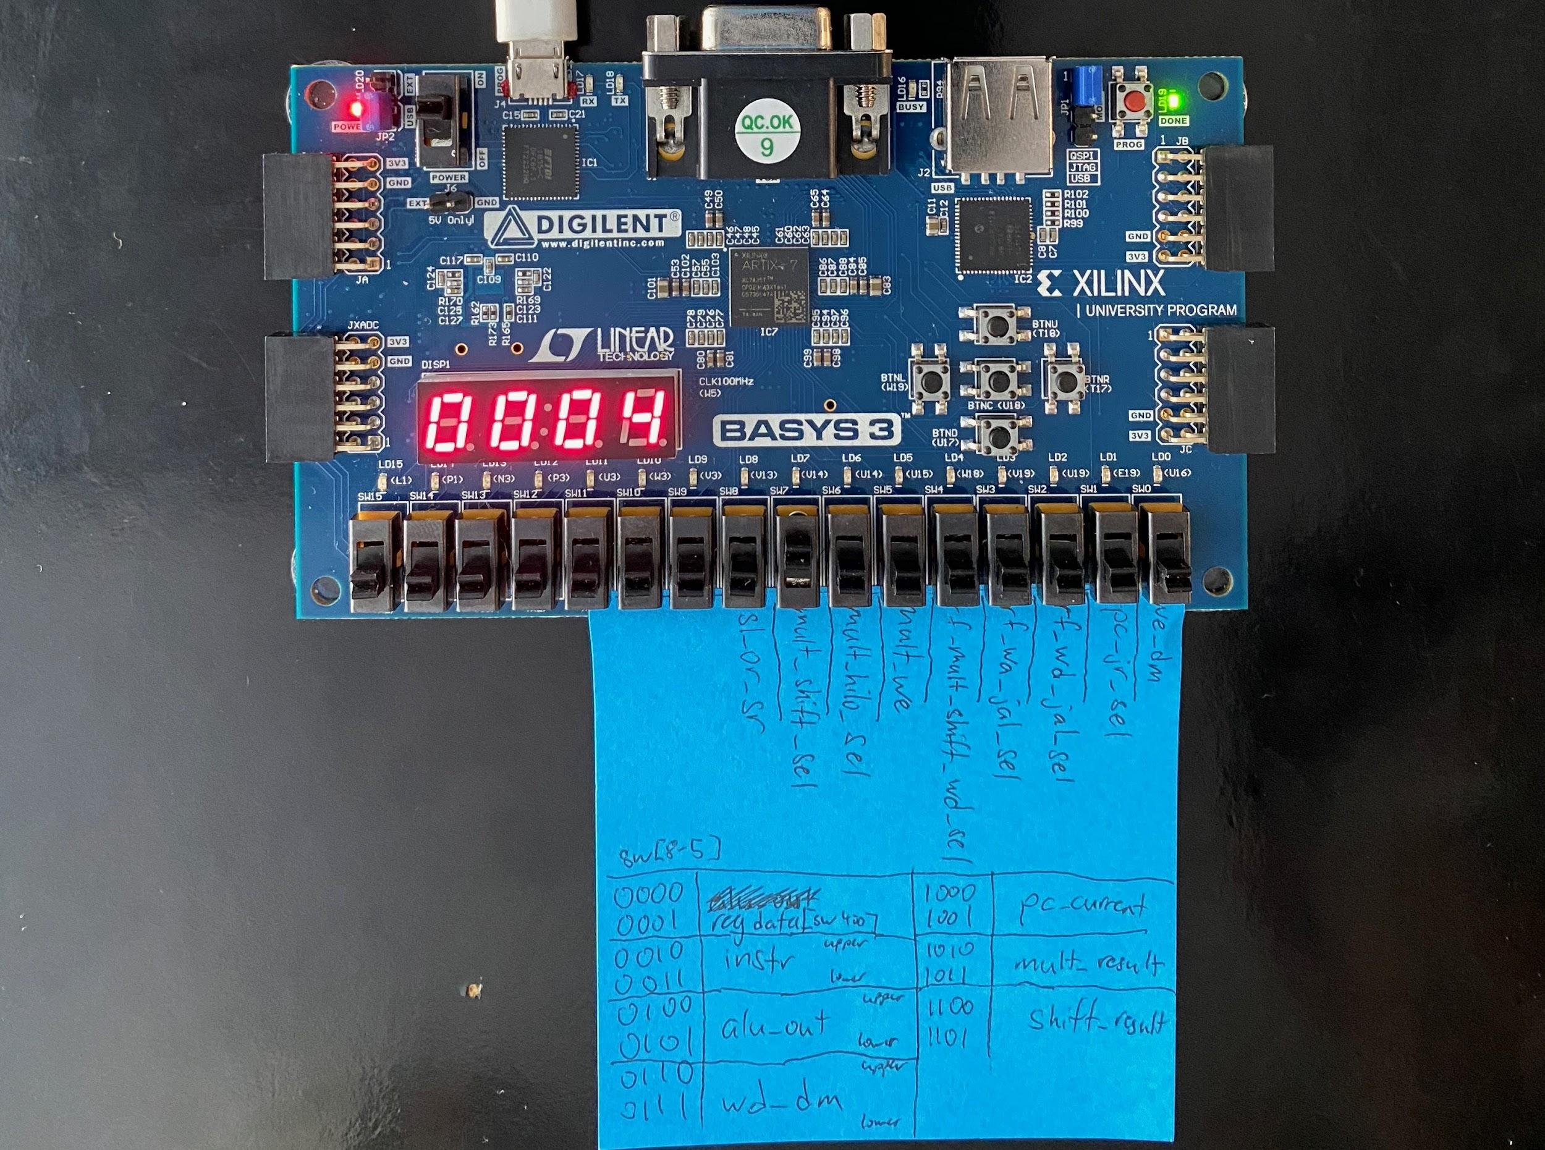

Figure 15. This picture shows the ALU output of the *addi $a0, $0, 4* instruction.

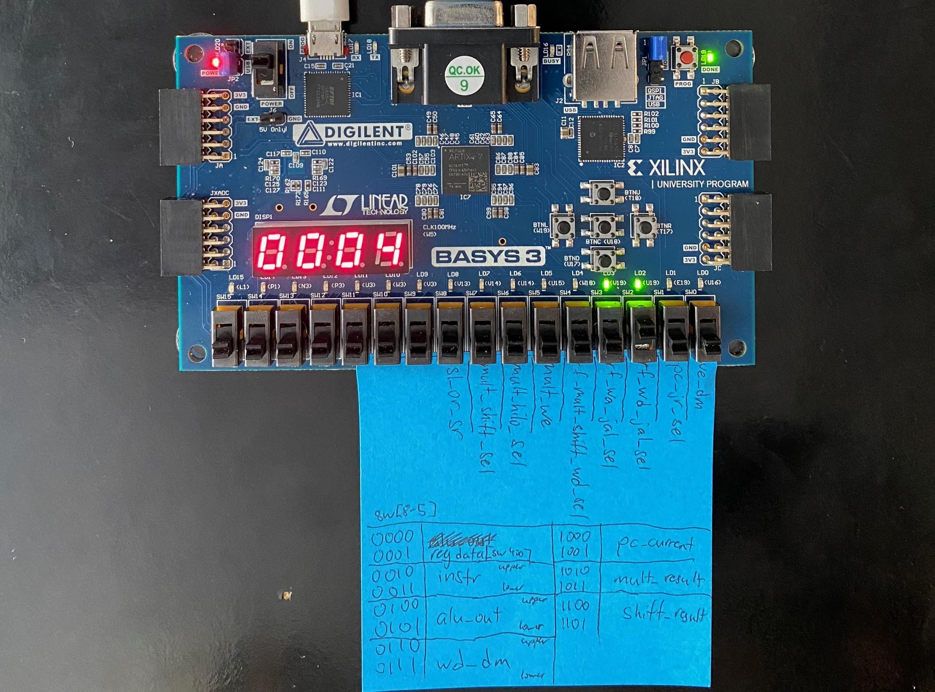

Figure 16. This picture shows the output of register $a0 or $4 after storing the input value n in it. Here, n = 4.

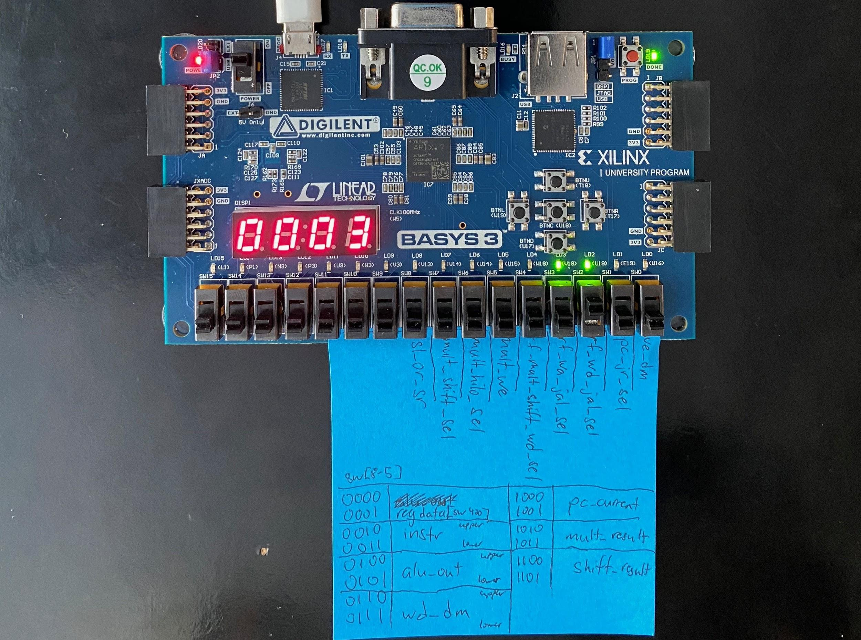

Figure 17. This picture shows the output of register $a0 which holds the value of n. Here, n = 3 because the driver assembly program has performed one recursive call in which n is decremented by 1.

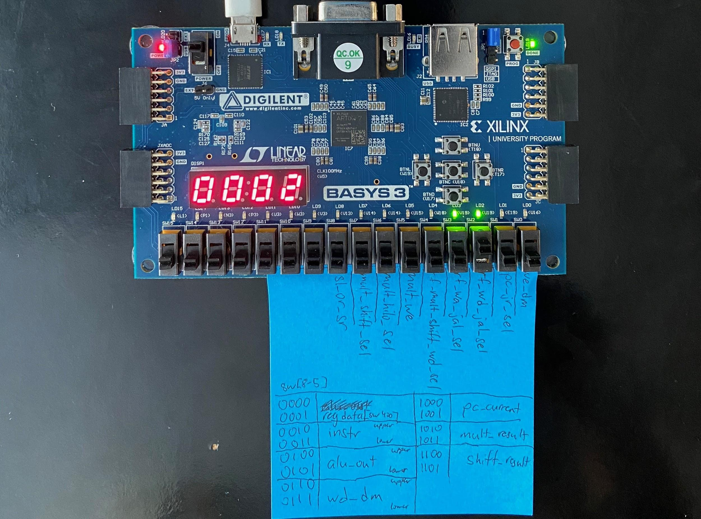

Figure 18. This picture shows the output of register $a0 which holds the value of n. Here, n = 2 because the driver assembly program has performed two recursive calls in which n is decremented by 1.

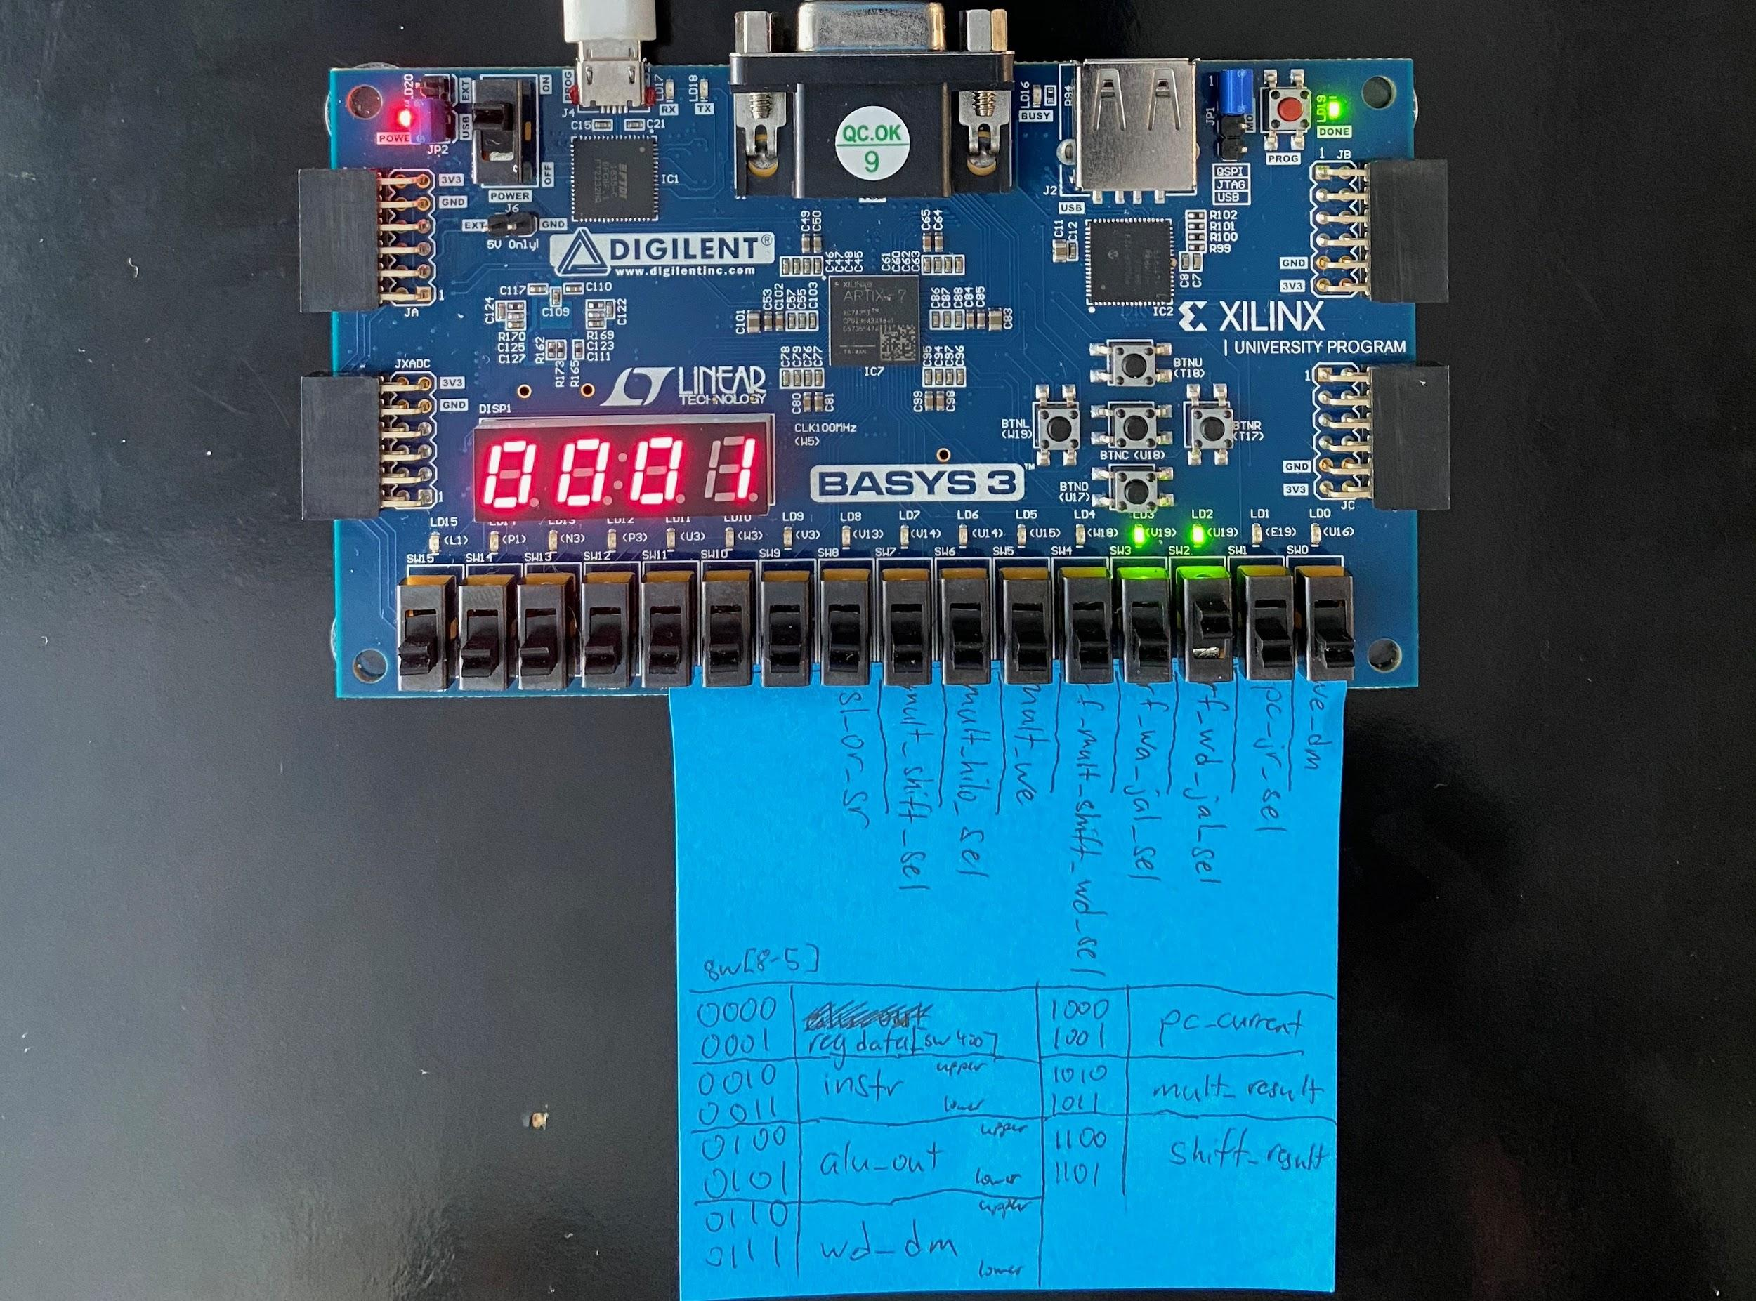

Figure 19. This picture shows the output of register $a0 which holds the value of n. Here, n = 1 because the driver assembly program has performed three recursive calls in which n is decremented by 1.

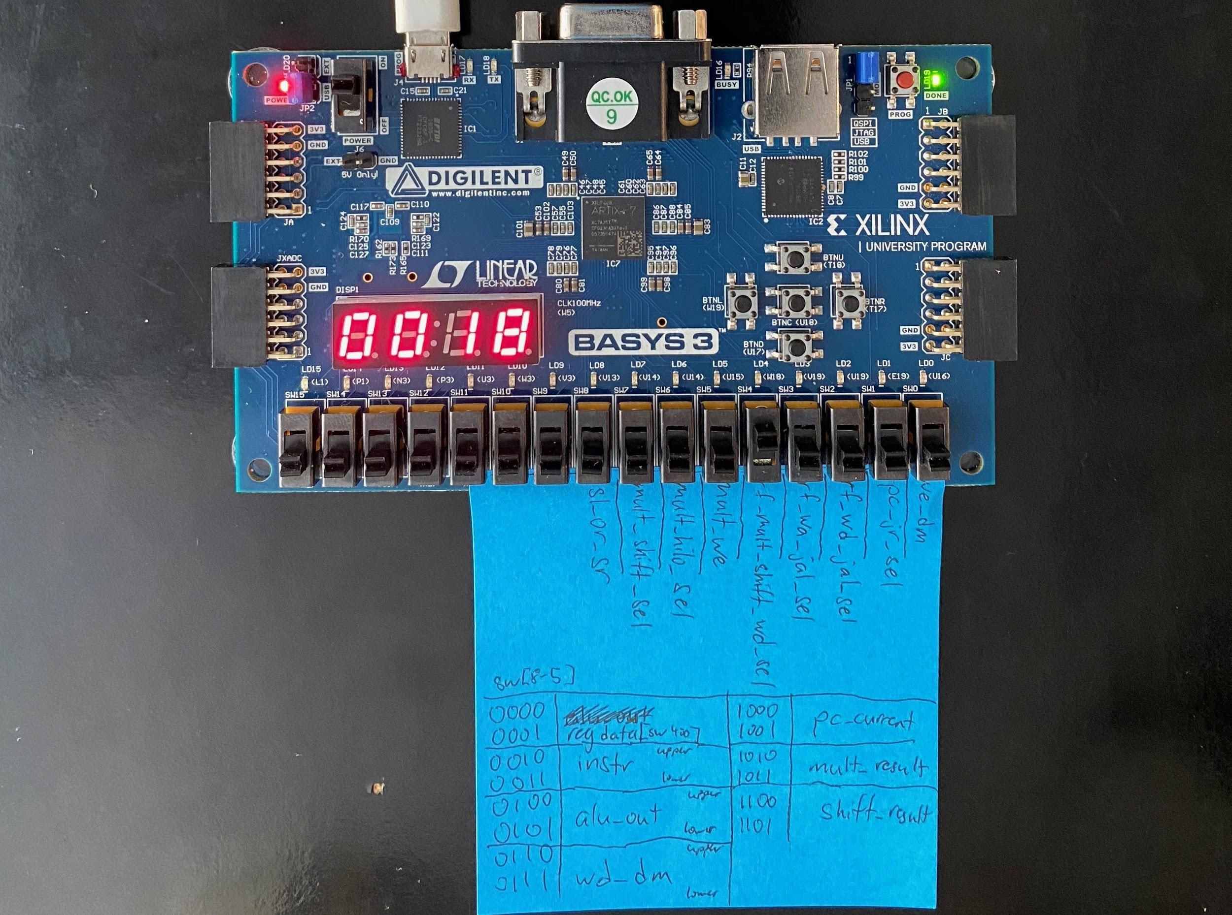

Figure 20. This picture shows the output of $v0 or register 16 which holds n! after the program has finished running. The program counter is currently paused at 0x0010, the final instruction to be executed in the program. Since n = 4 for this program, n! = 18 which is correctly shown on the FPGA board indicating proper hardware validation of the single-cycle MIPS processor.

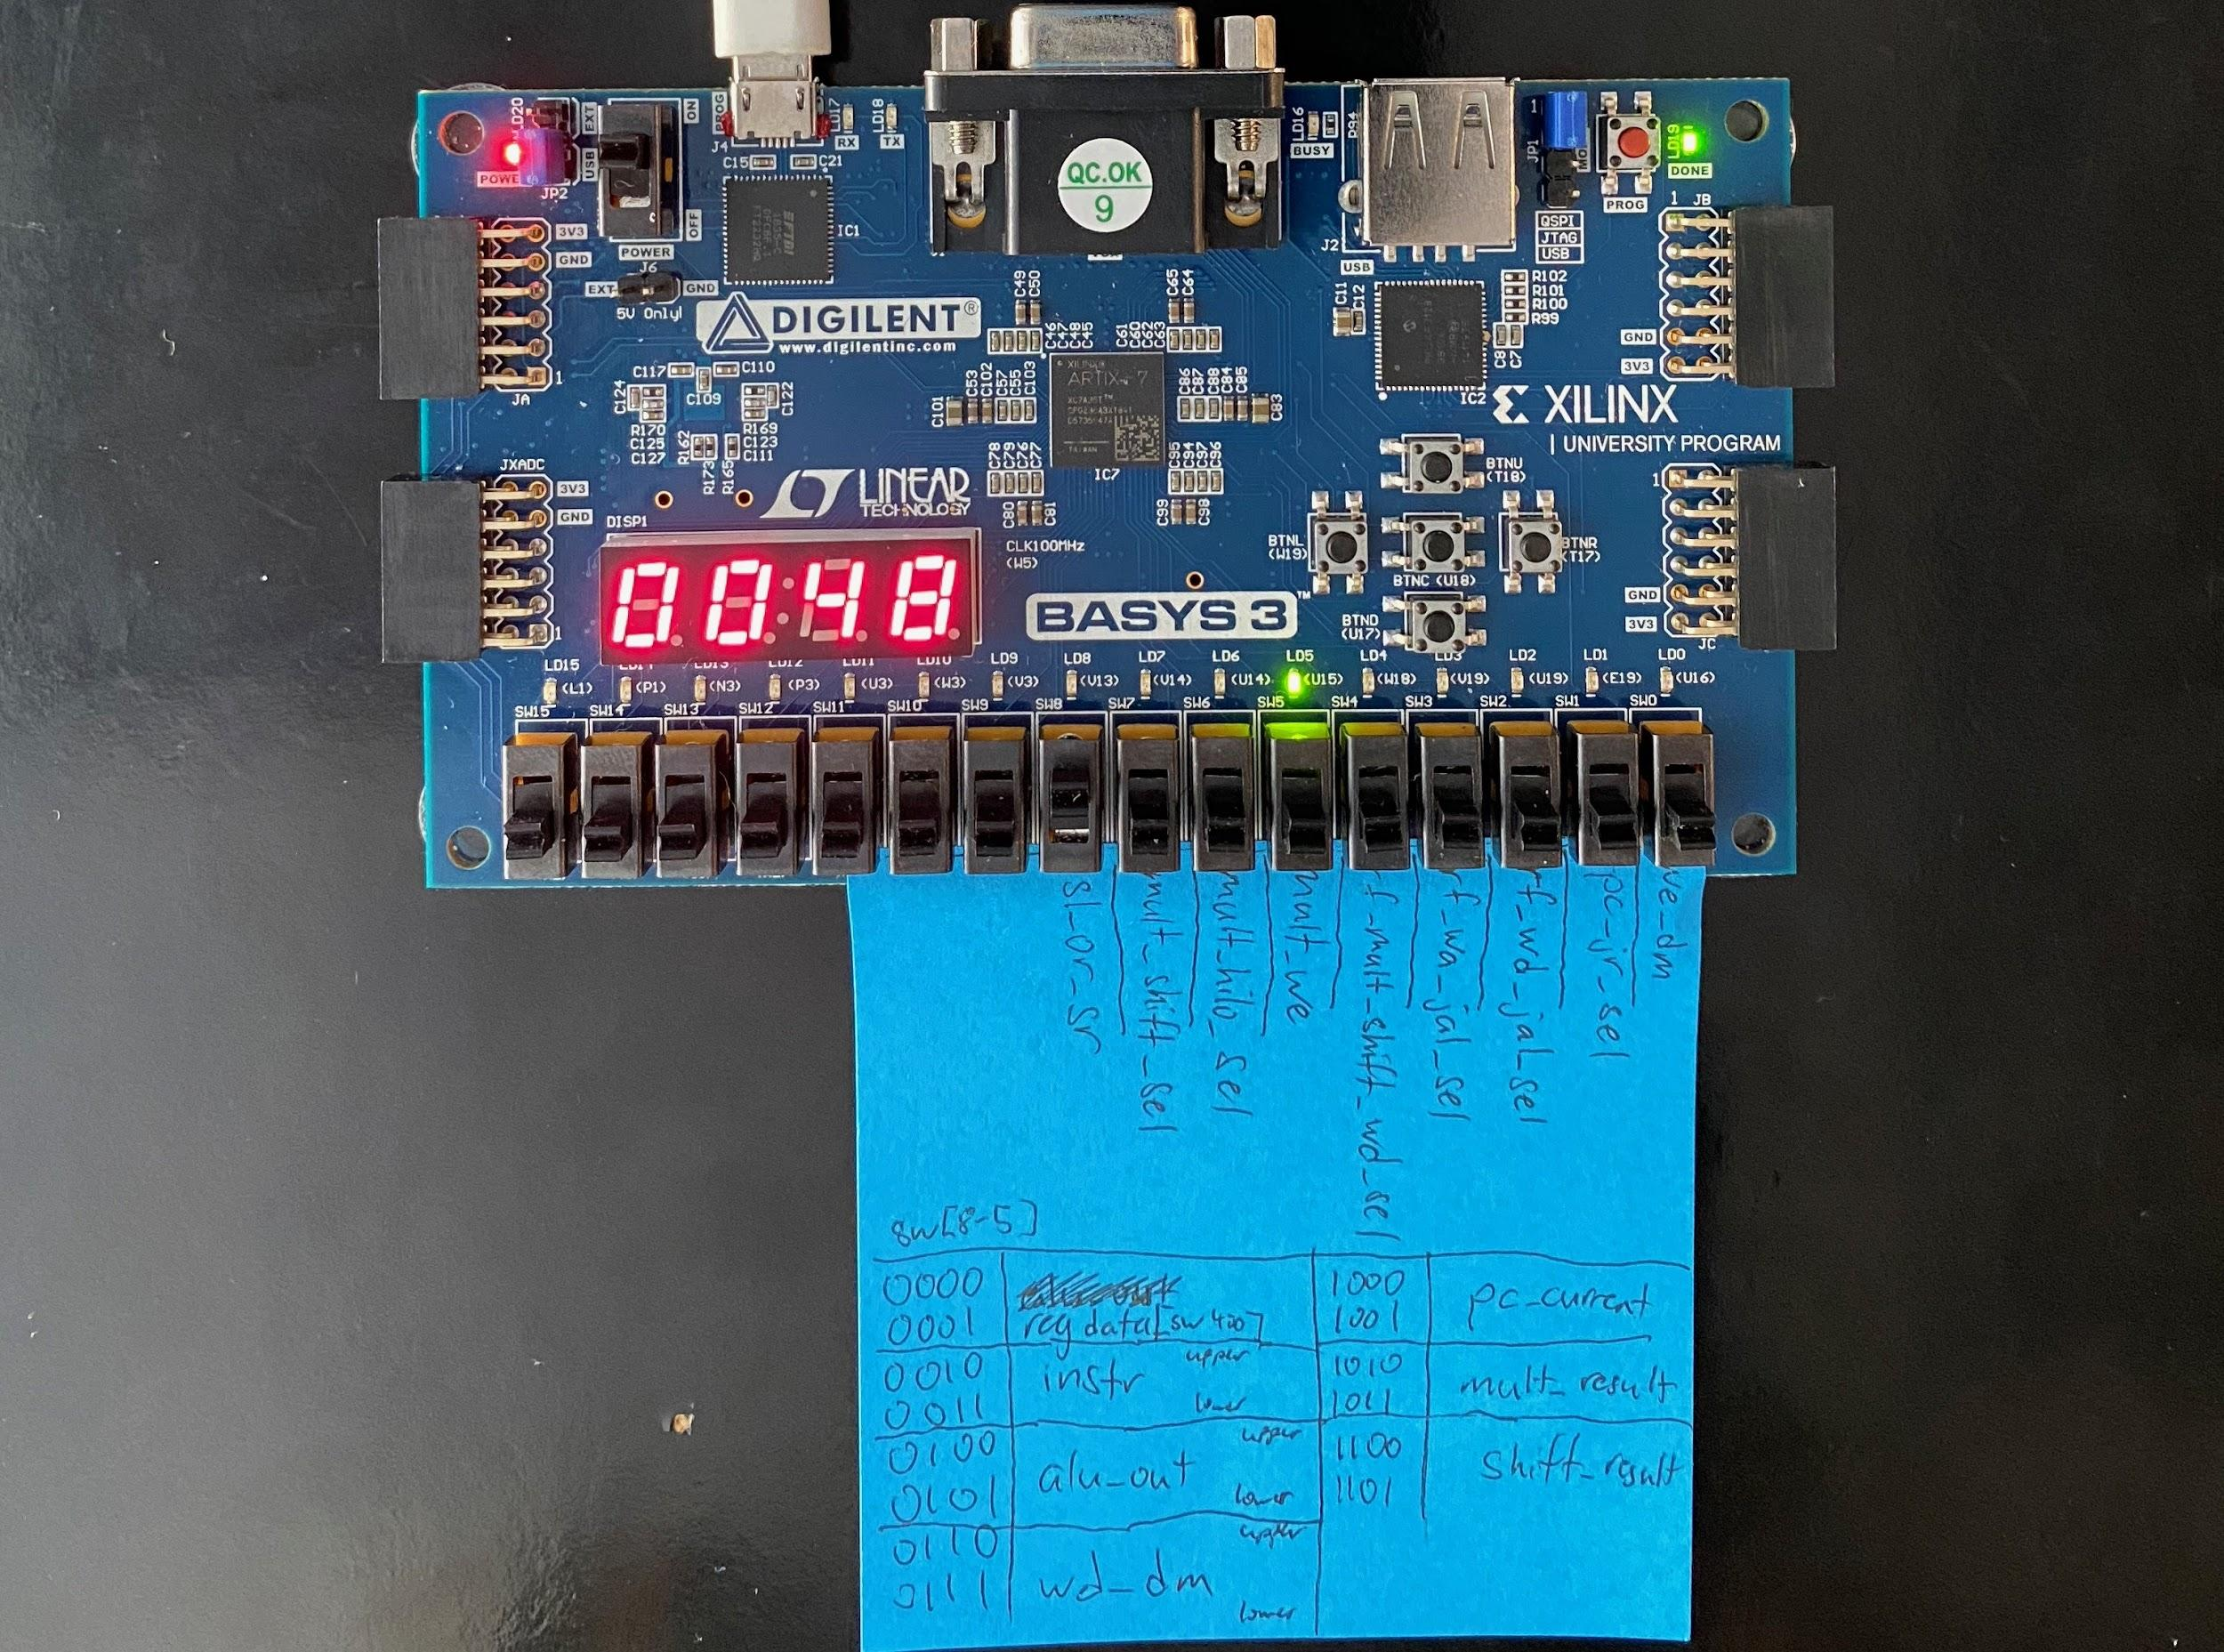

Figure 21. This picture shows the output control signals of a MULTU instruction. The 7-segment display shows the program counter of the current instruction: *multu $a0, $v0*. Since MULTU multiplies two input blocks of data, it enables the mult_we signal (LD5) to store the output data of the operation into the HI and LO registers.

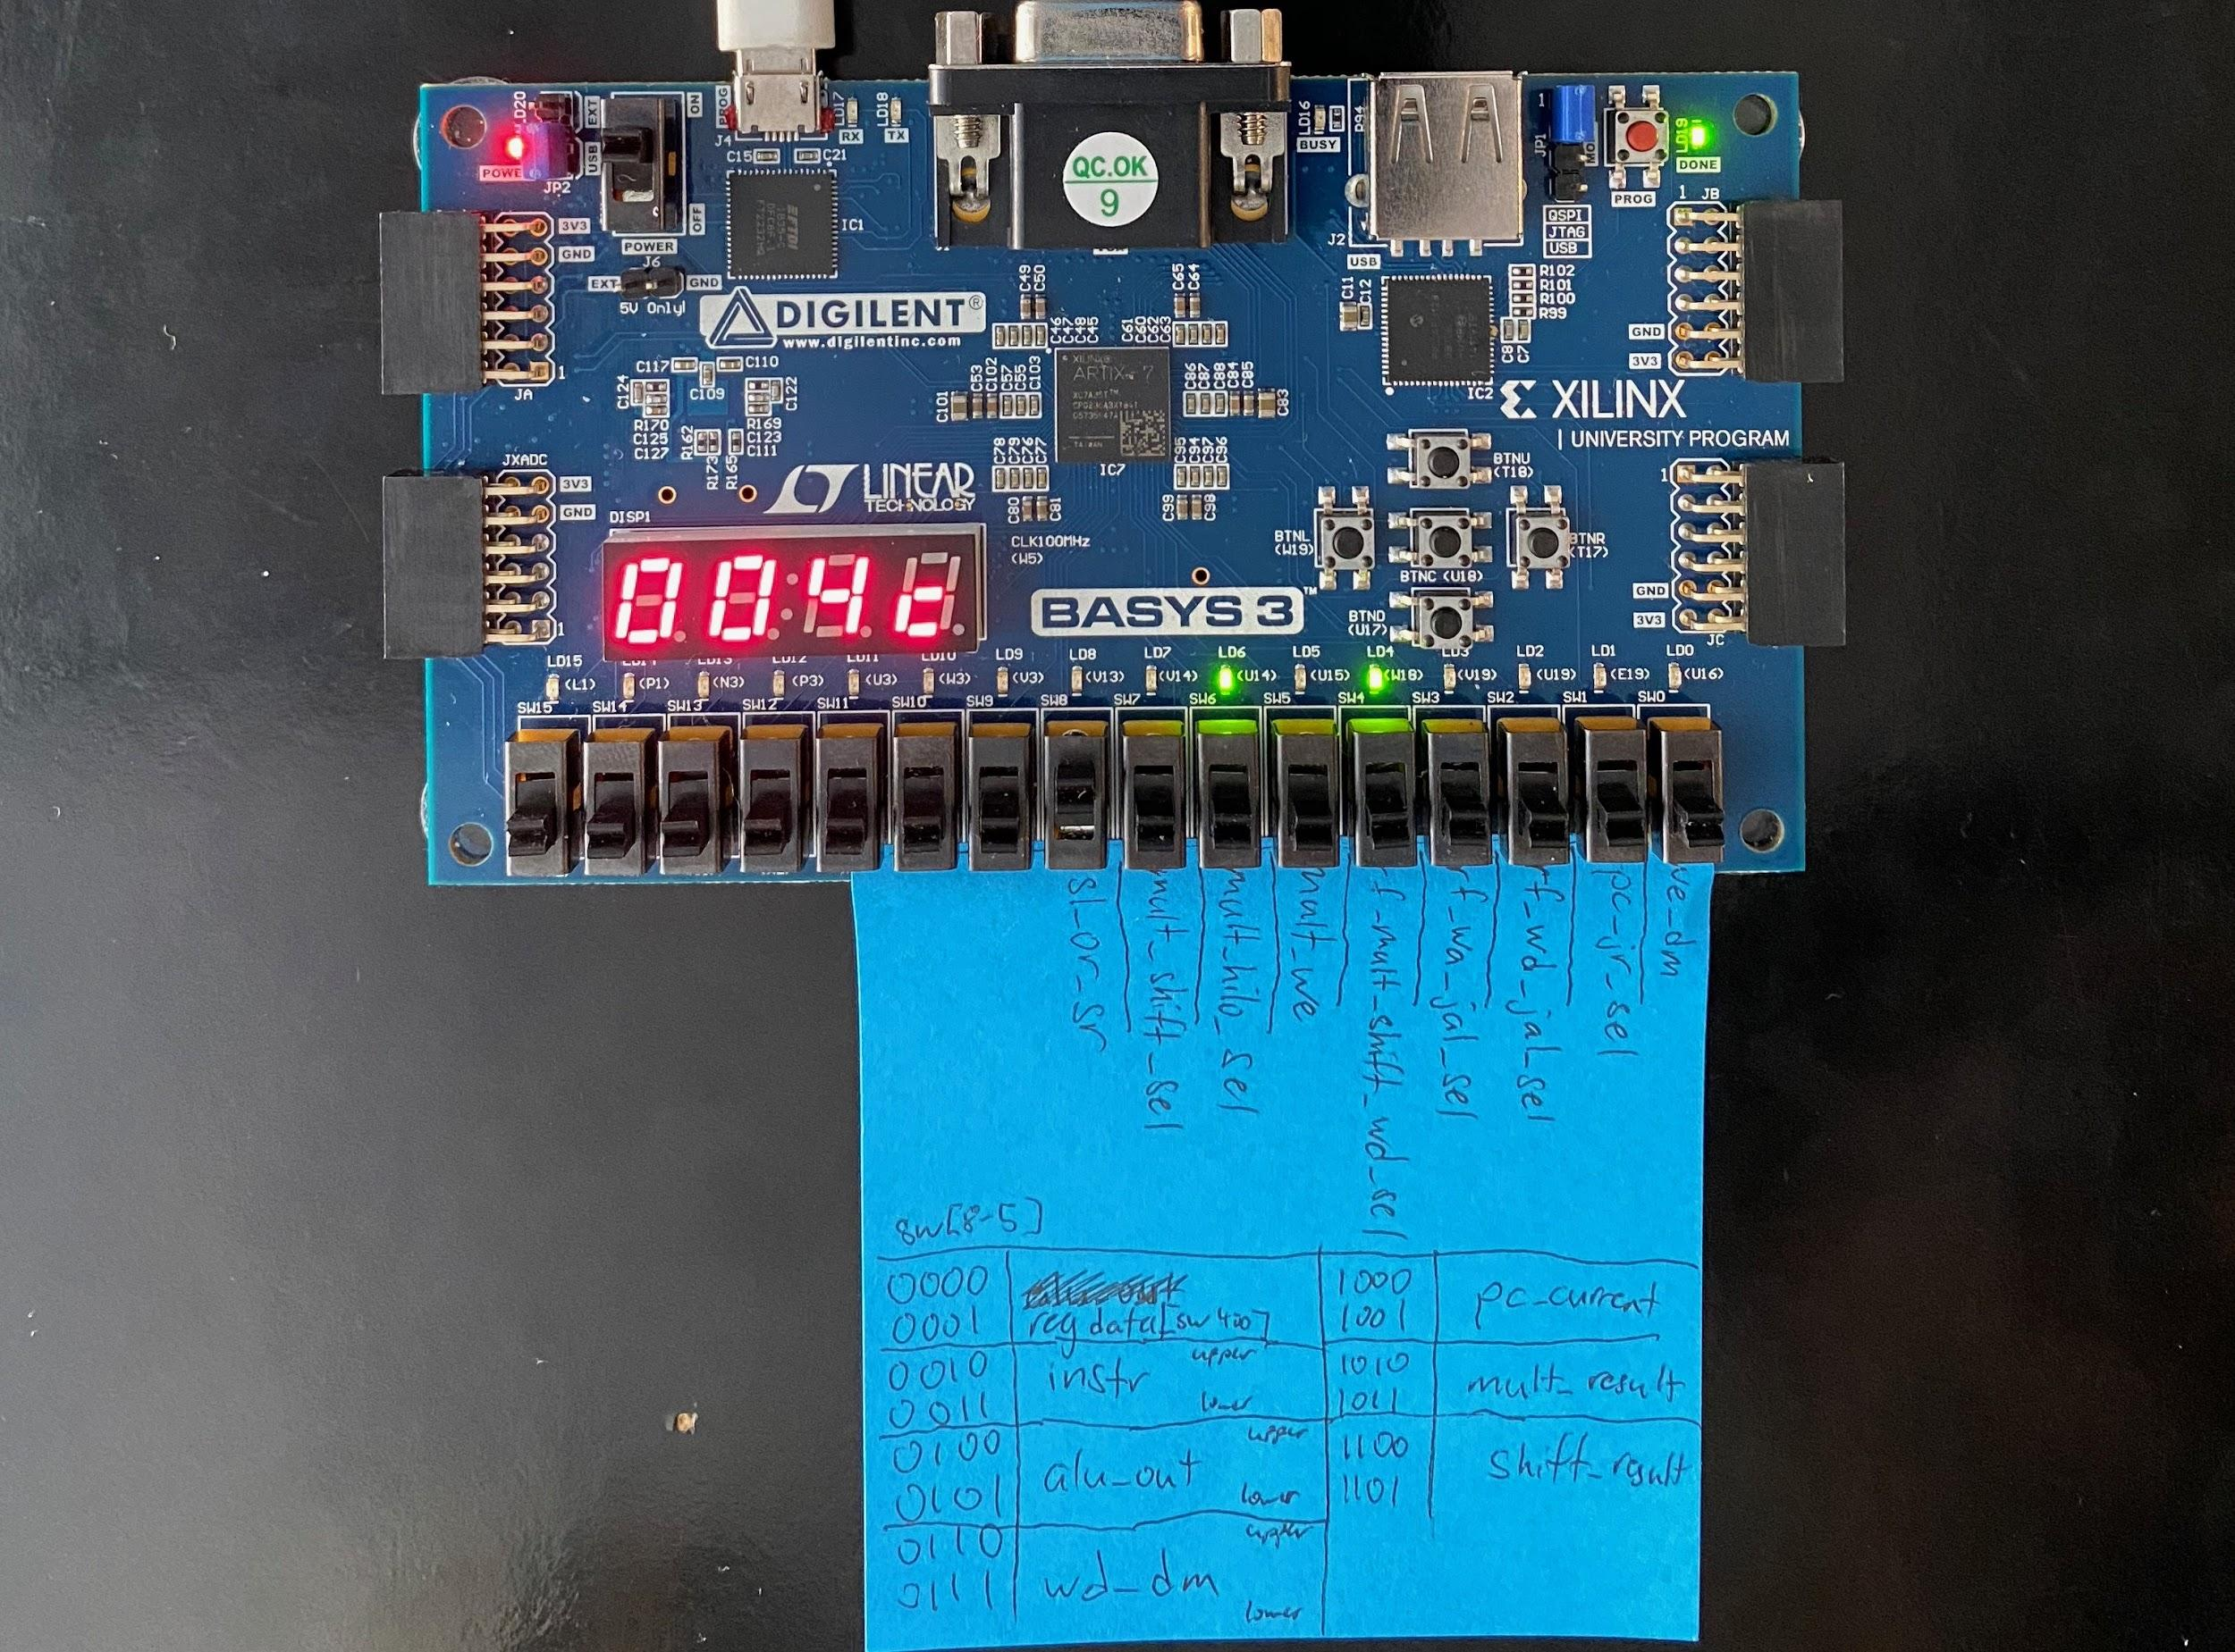

Figure 22. This picture shows the control signals of a MFLO instruction. Execution is paused at 0x004C for the following instruction: *mflo $v0*. Since this is a MFLO instruction, mult_hilo_sel (LD6) is high to forward data from the LO register. Additionally, rf_mult_shift_wd_sel (LD4) is high to forward data from the multiplication modules to the register file.

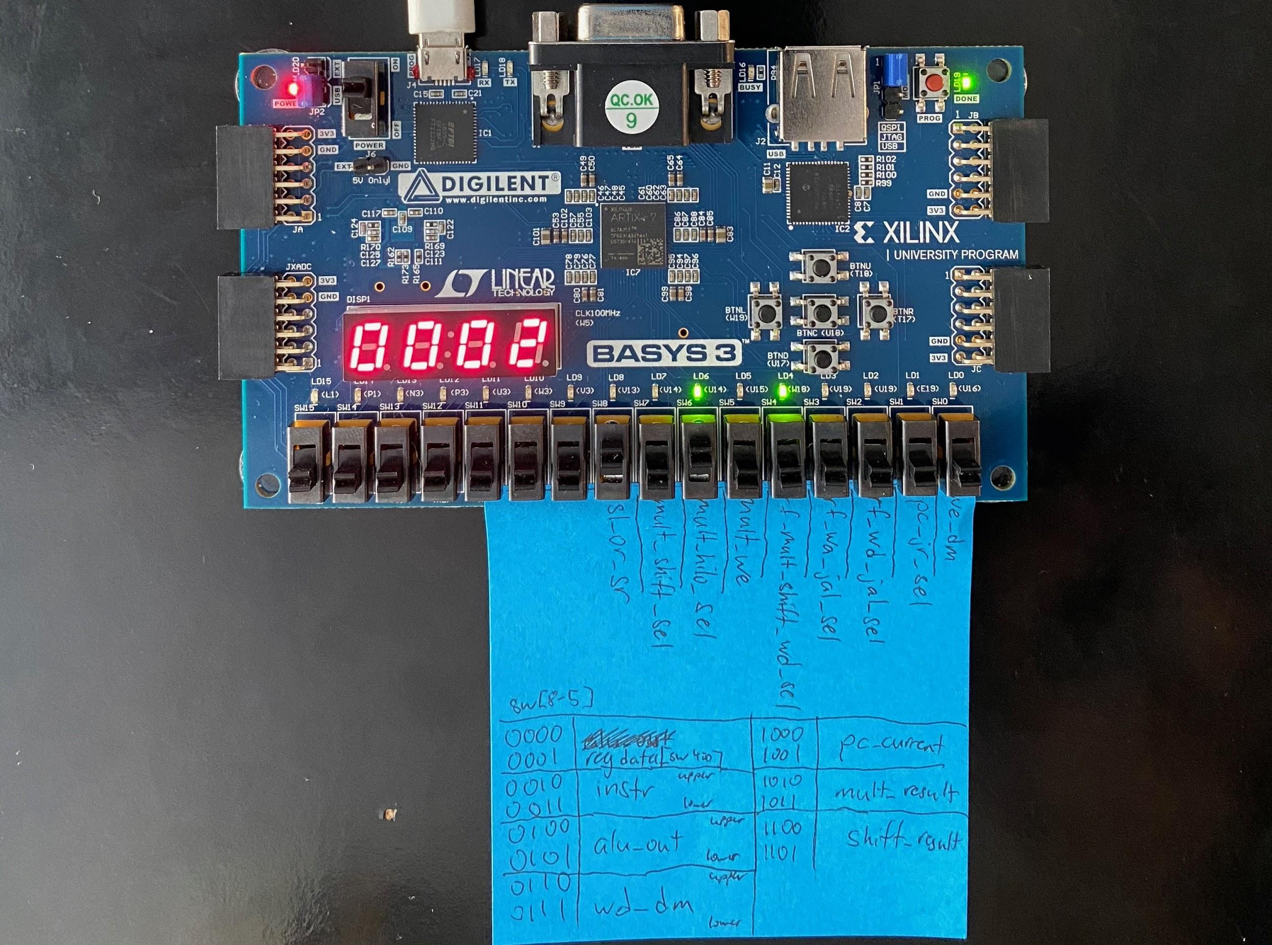

Figure 23. This picture shows the output of the *mflo $v0* instruction by selecting mult_result to be shown on the 7-segment display. Simulation shows that the output of this instruction should be 2 which is validated in hardware.

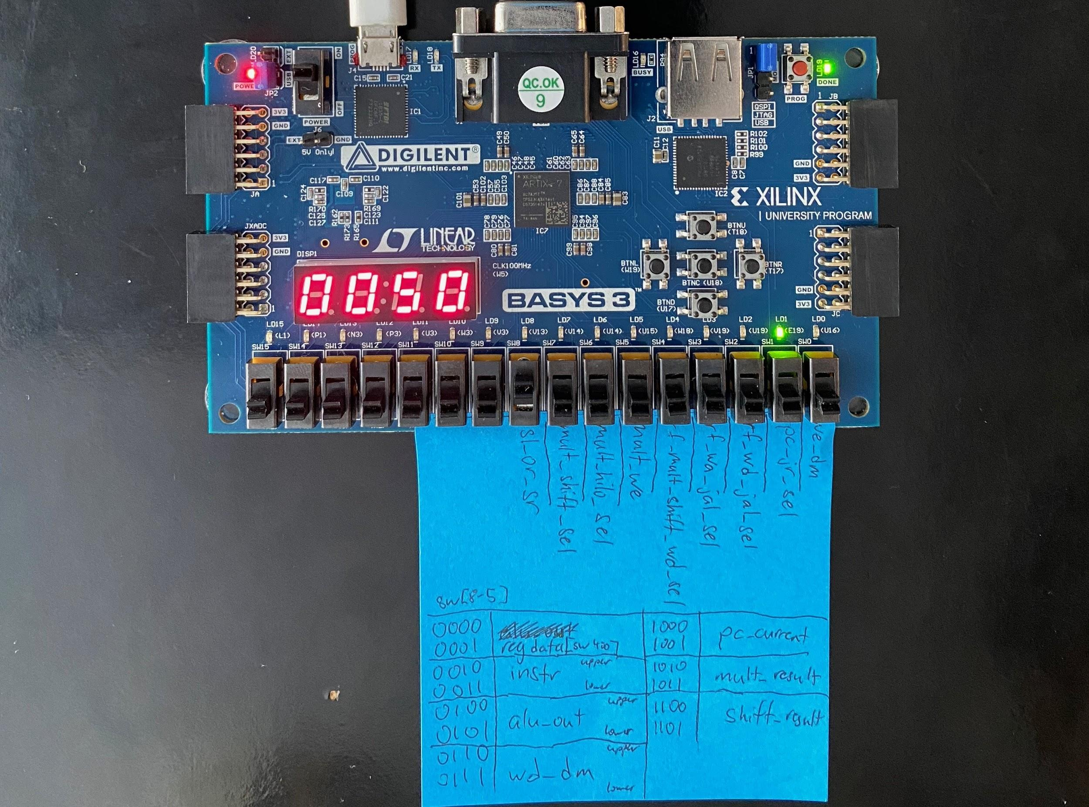

Figure 24. This picture shows execution of a JR instruction, specifically *jr $ra*. In this instruction, the pc_jr_sel (LD1) control signal lights up the LED because an address from the $ra register in the register file is being forwarded to the program counter register. This control signal is selecting the correct port on the pc_jr_mux multiplexor.

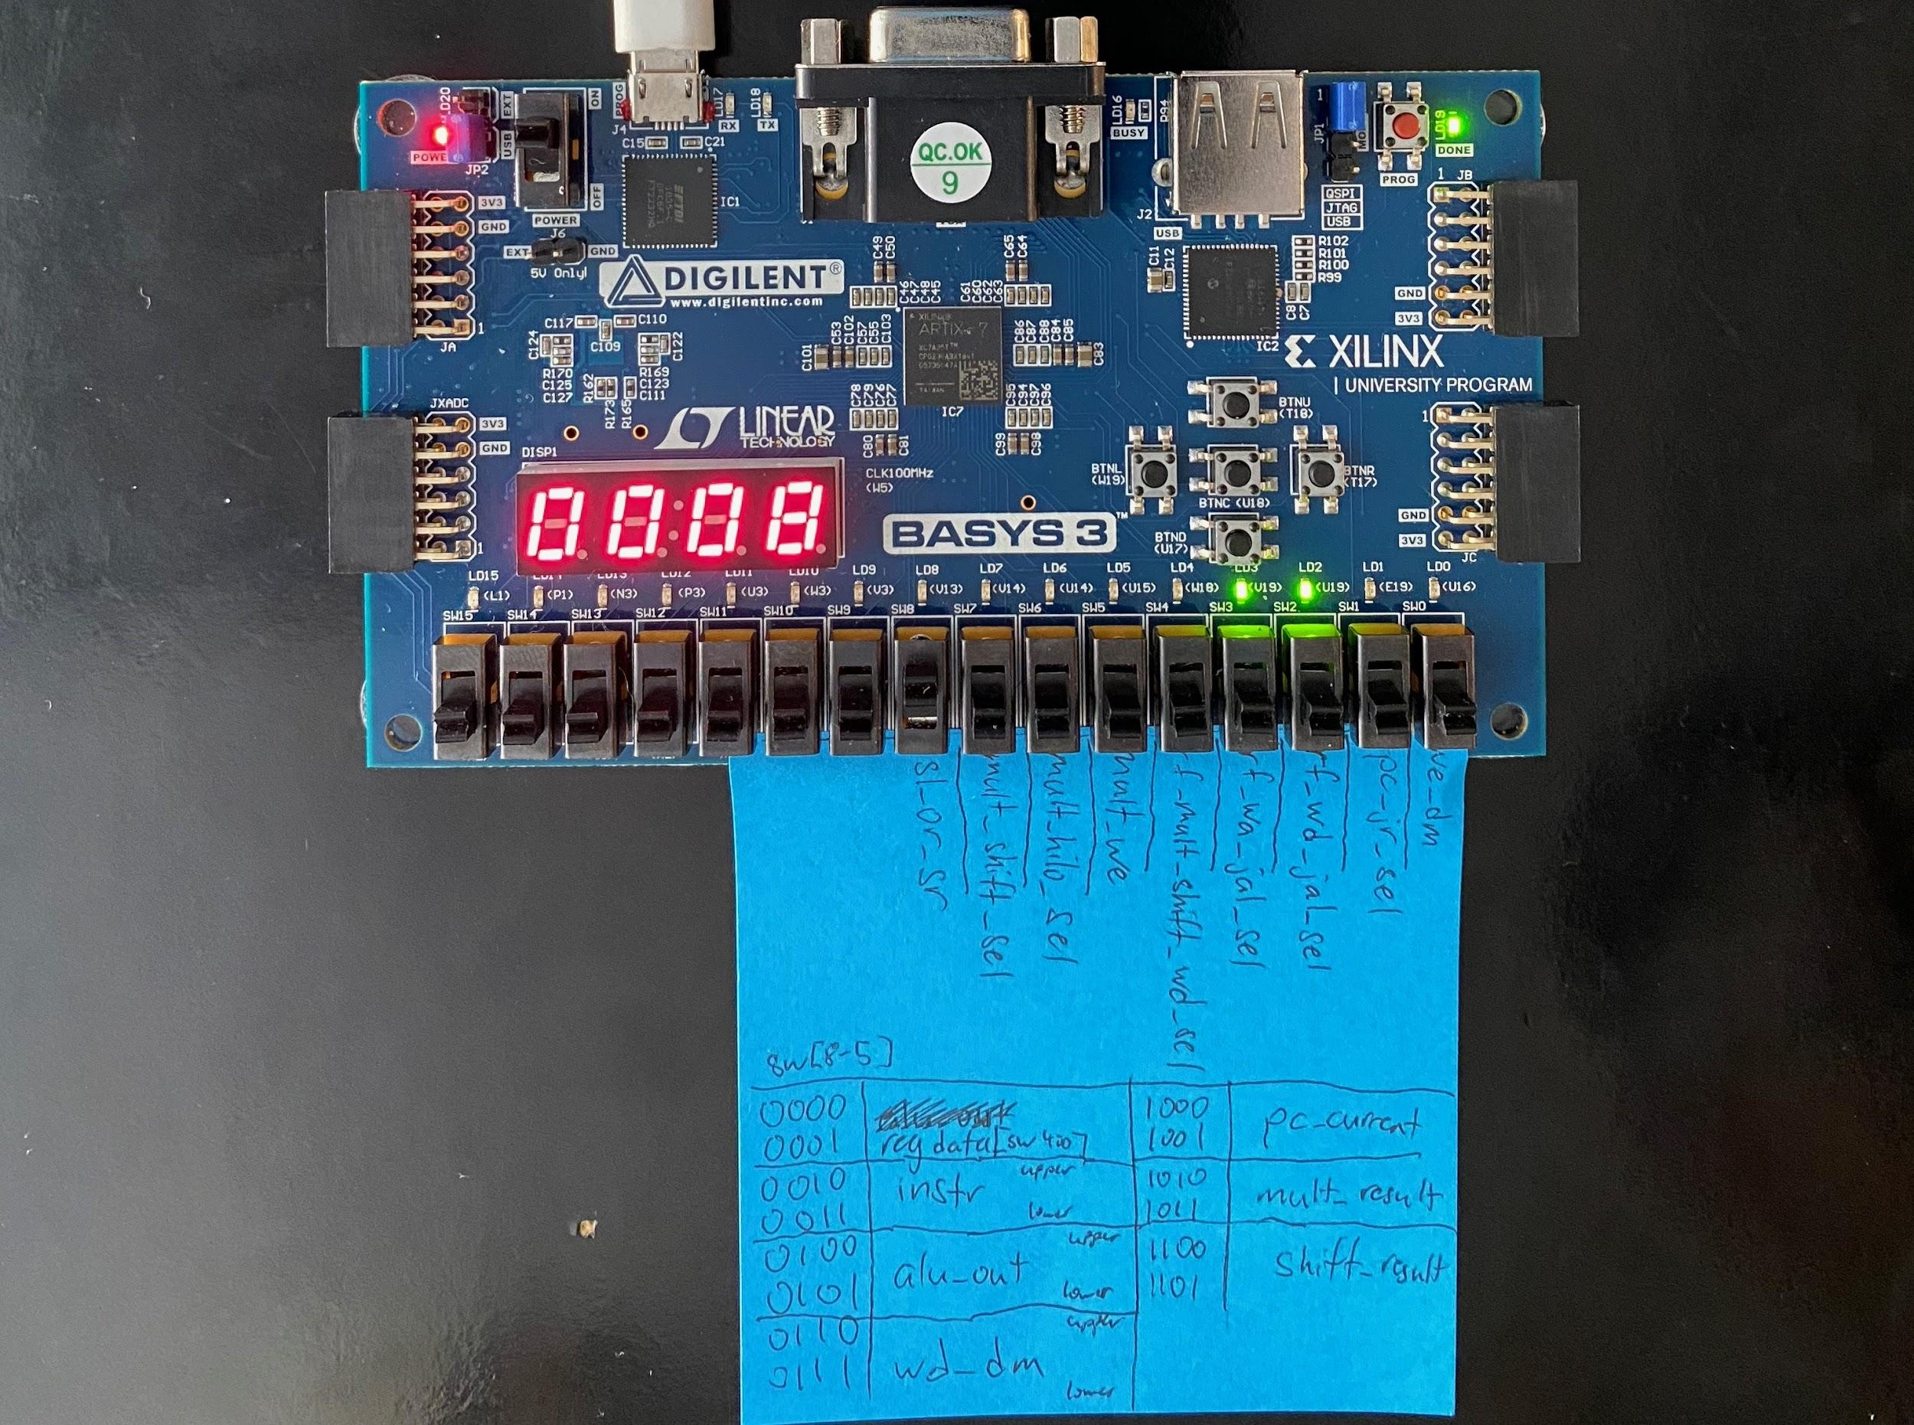

Figure 25. This picture shows execution of a JAL instruction, specifically *jal factorial*. The control signals relevant in this picture are rf_wd_jal_sel (LD2) and rf_wa_jal_sel (LD3). Since these LEDs are lit, that means that the address of the next instruction is correctly being stored in register 31 in the register file. Additionally, although not shown, the jump control signal is high indicating that the correct address is being forwarded to the program counter register.

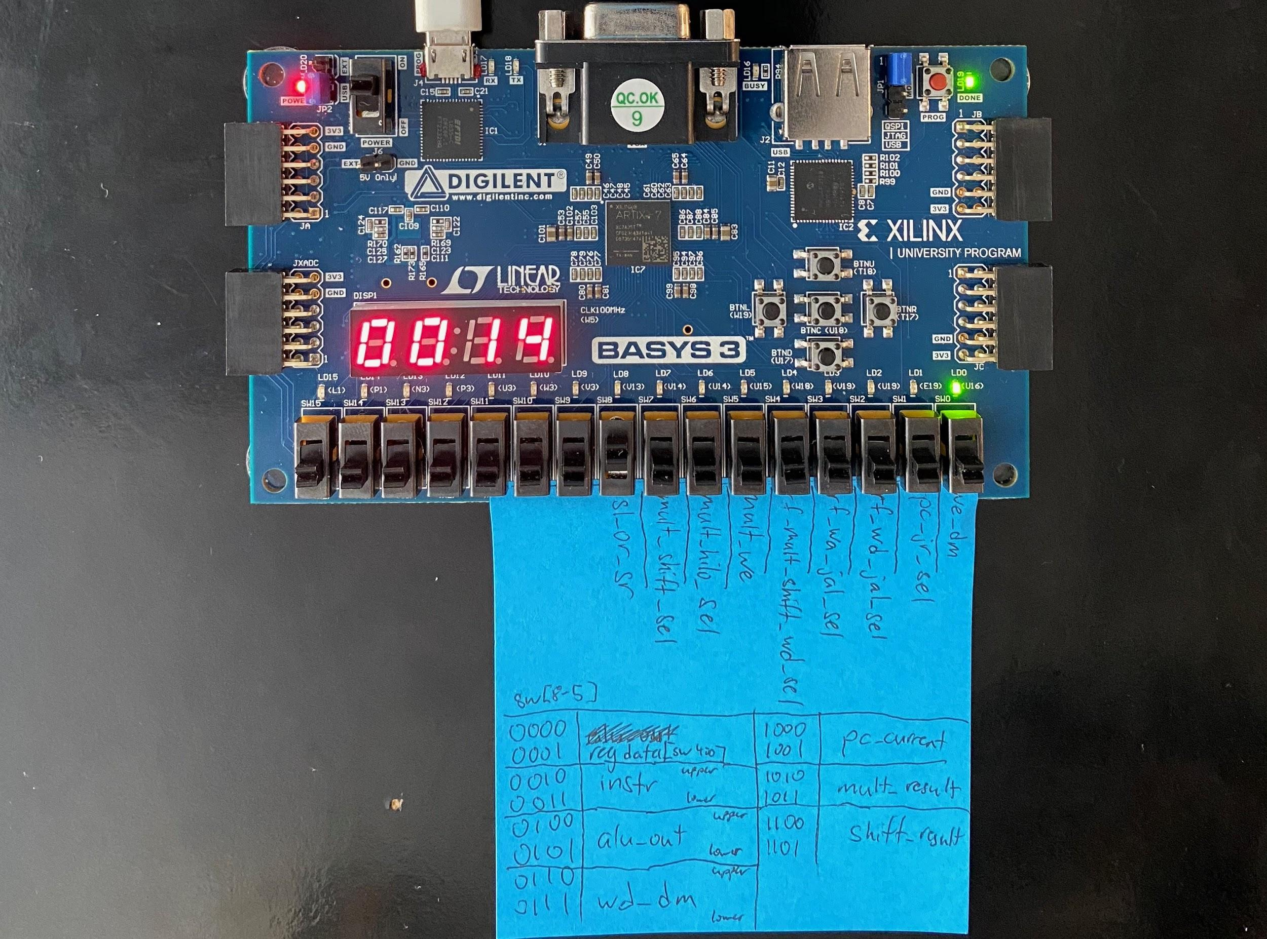

Figure 26. This picture shows execution of a save word instruction, specifically *sw $a0, 4($sp)*. we_dm (LD0) is high and the respective LED is lit indicating proper execution of this instruction. Data is correctly being stored to memory.